**Table of Contents**

Can I Run My Application in parallel?: p. 1-16

The Parallel Package: p. 18-40

Foreach, future.apply, and Load Balancing: p. 42-56

Random Numbers and Reproducibility: p. 58-73

Parallel programming in r

R Programming

**Can I Run My Application in Parallel?**

In this introductory chapter, you will learn about different ways of partitioning and how it fits different hardware configurations. You will also be introduced to various R packages that support parallel programming.

# Partitioning demographic model

Consider a demographic projection model at time t: Population(t) = Population(t-1) + Births(t) - Deaths(t) + Net Migration(t), consisting of four submodels, namely for projecting births, deaths, migration and population at time t-1. How can this model be split into independent pieces that could run in parallel?

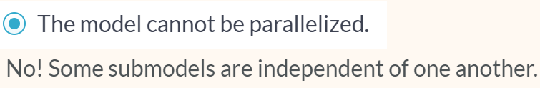

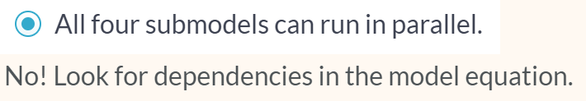



Correct; Projecting population depends on births, deaths and migration; therefore it cannot run independently of those sub models. You just partitioned a problem by TASK!

# Partitioning probabilistic demographic model

Now consider a probabilistic version of the previous model. In this case, each of the four submodels processes a set (not just one) of independent trajectories of their respective quantity. How can this model be parallelized?

* A. Now the Population submodel can also run independently of the other three submodels.
* B. Each submodel can process each trajectory in parallel to other trajectories.
* C. Submodels Births, Deaths and Migration can run independently of one another but no parallelization within the submodels.
* D. The Population submodel can be only parallelized by trajectories.

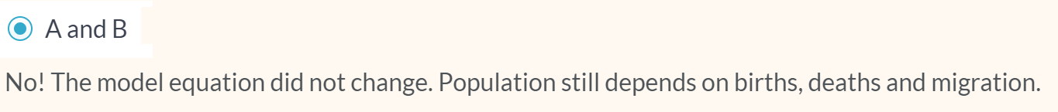





Yes! Trajectories are independent of one another; therefore they can be processed in parallel in all four submodels including Population. Congratulations, you just partitioned a problem by DATA! The same task (submodel) is applied to different data (trajectories).

# Find the most frequent words in a text

We will now turn to partitioning by data. Here is an example that will be used throughout the course: In the given text, find the most frequent words that start with each letter of the alphabet and are at least a given length long.

You'll use the janeaustenr package with its 6 books by Jane Austen, which is available in your environment. Also loaded are the stringr package and the function janeausten_words(), which extracts words from the 6 books and converts them to lowercase.

Here, the specific task is to find, for each letter of the alphabet, the most frequent word that is at least five characters long. Your job is to partition this task into independent pieces.

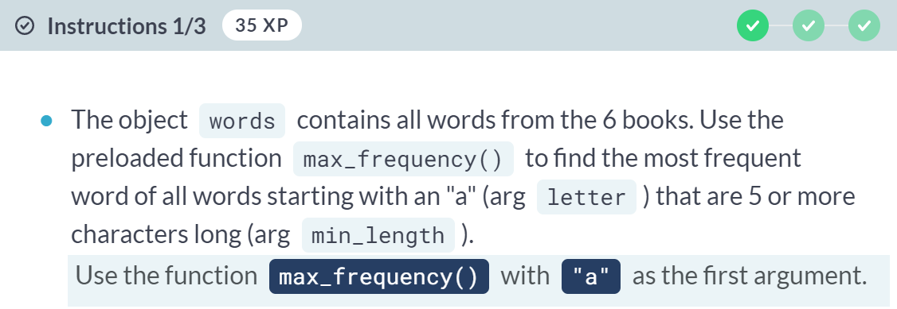

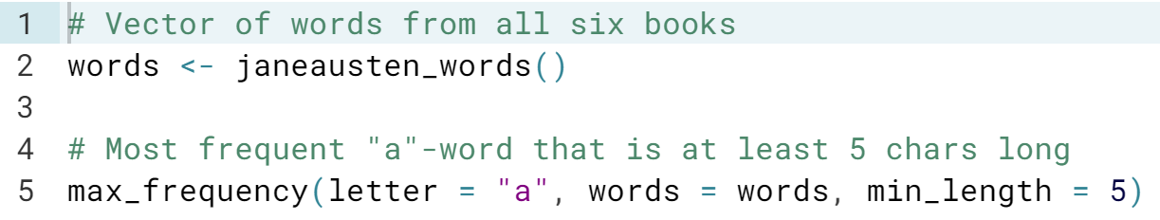

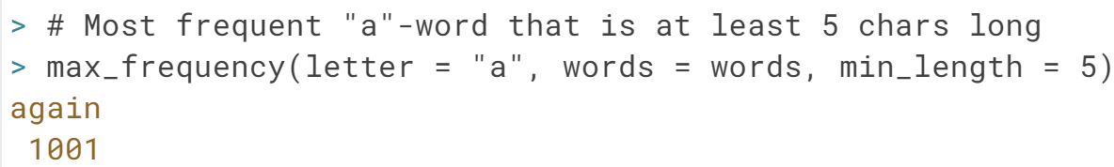

(Exercise continues on the next page)

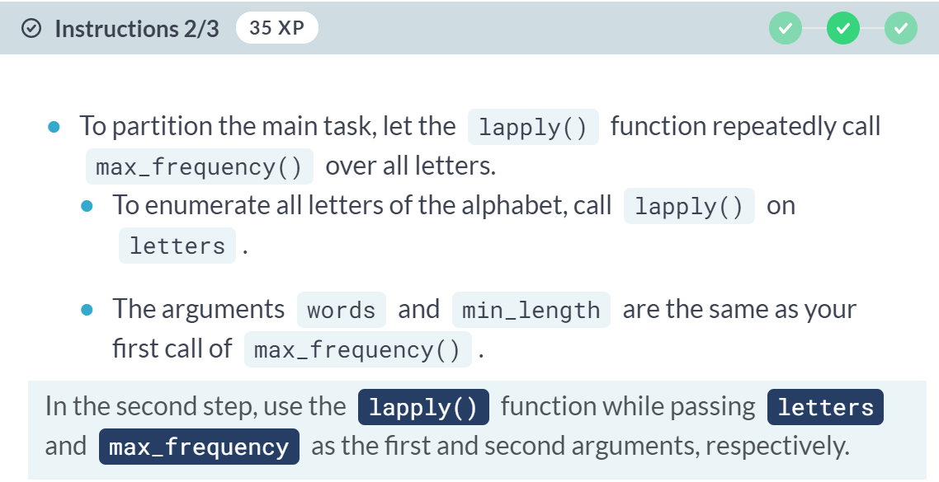

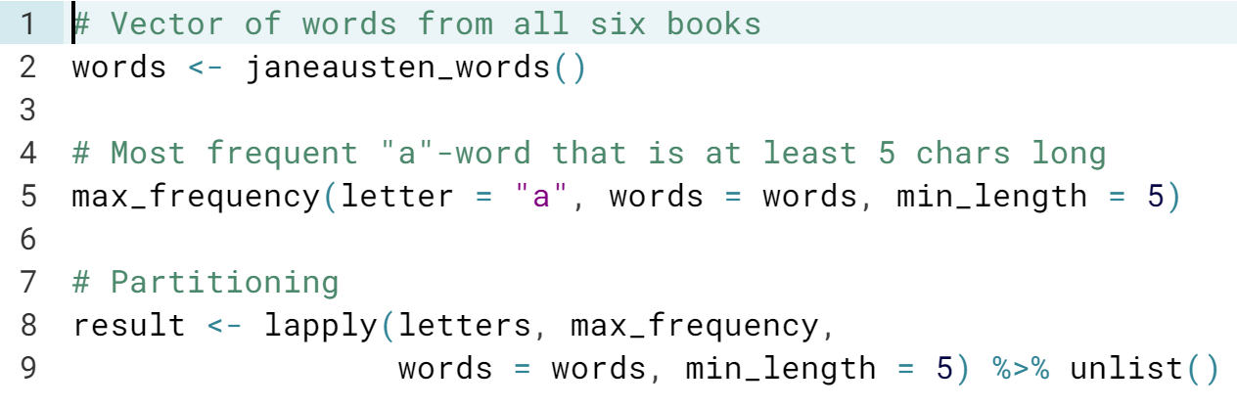

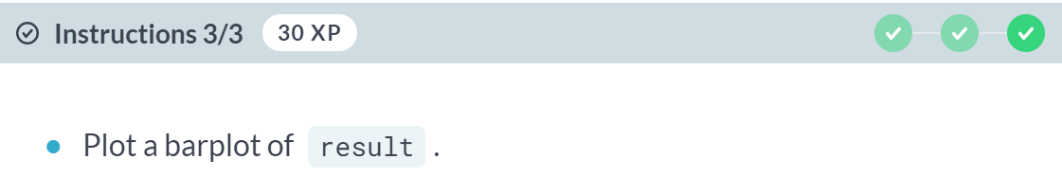

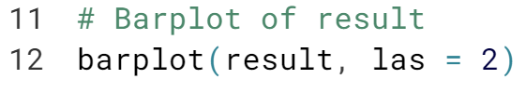  
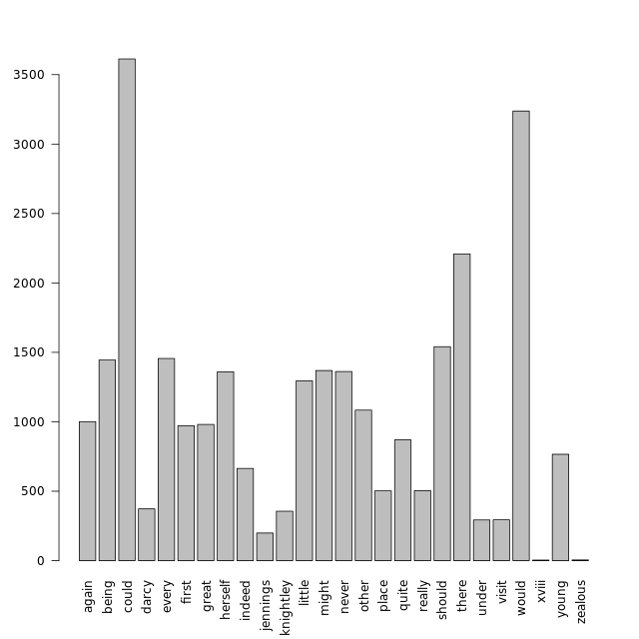

# A simple embarrassingly parallel application

As a simple example of an embarrassingly parallel statistical application, we will repeatedly compute the mean of a set of normally distributed random numbers. For now, you will process it sequentially using a for loop, and the sapply() function.

In general, we recommend implementing any task that will be repeatedly applied to data as a function. Here, the function will be called mean_of_rnorm(). It generates random numbers with rnorm(), then computes their mean.

The objects n_numbers_per_replicate (set to 10000) and n_replicates (set to 50) have been created for you and determine the length of the random numbers vector and how many times the task is repeated, respectively.

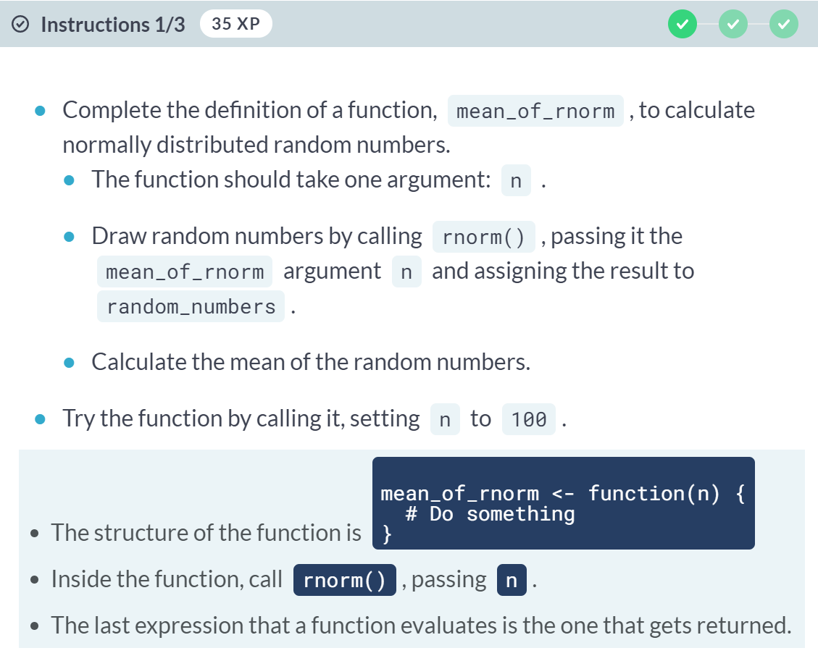  
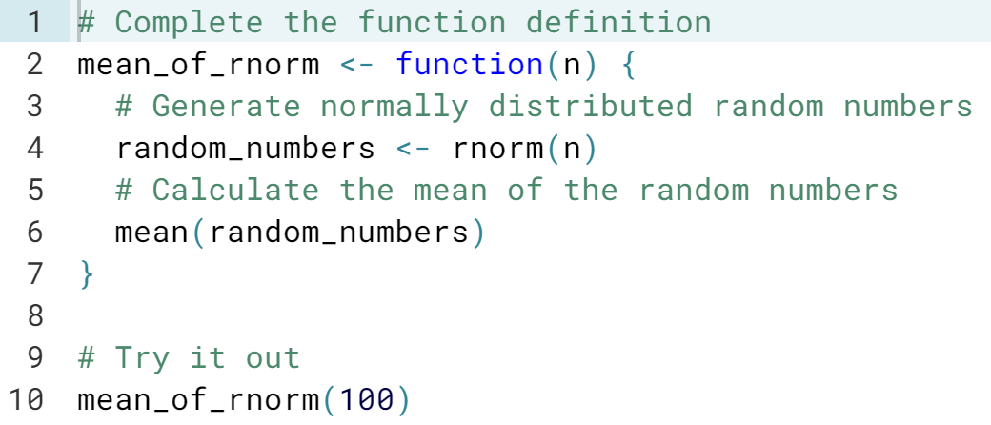  
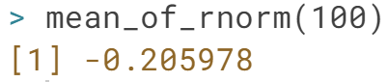  
(Exercise continues on the next page)

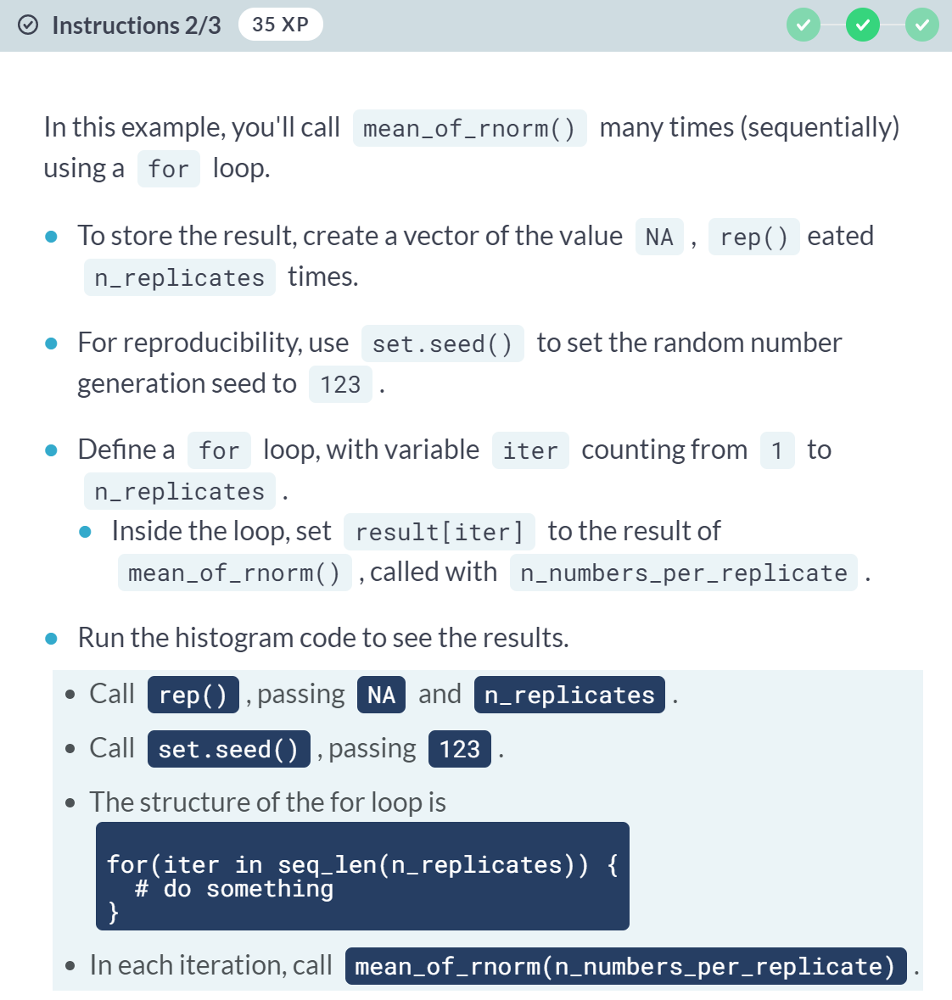

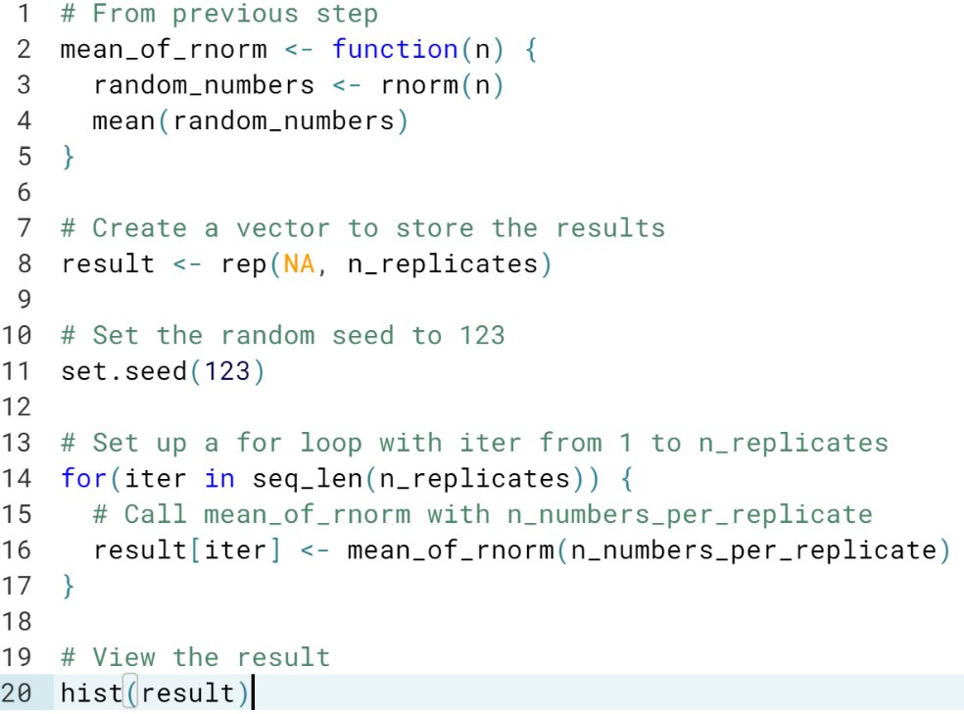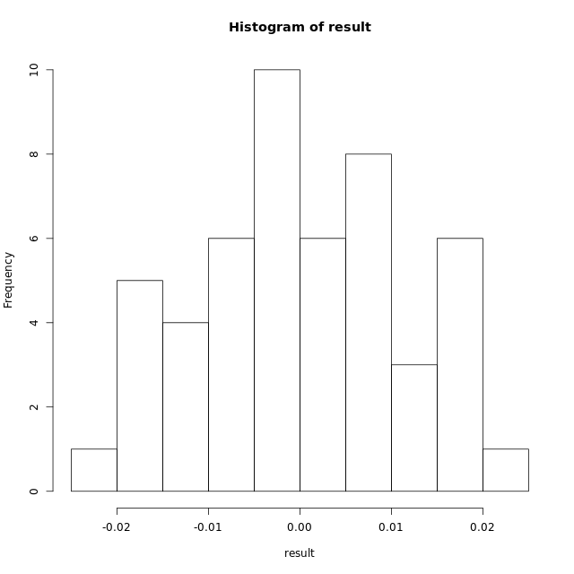  
(Exercise continues on the next page)

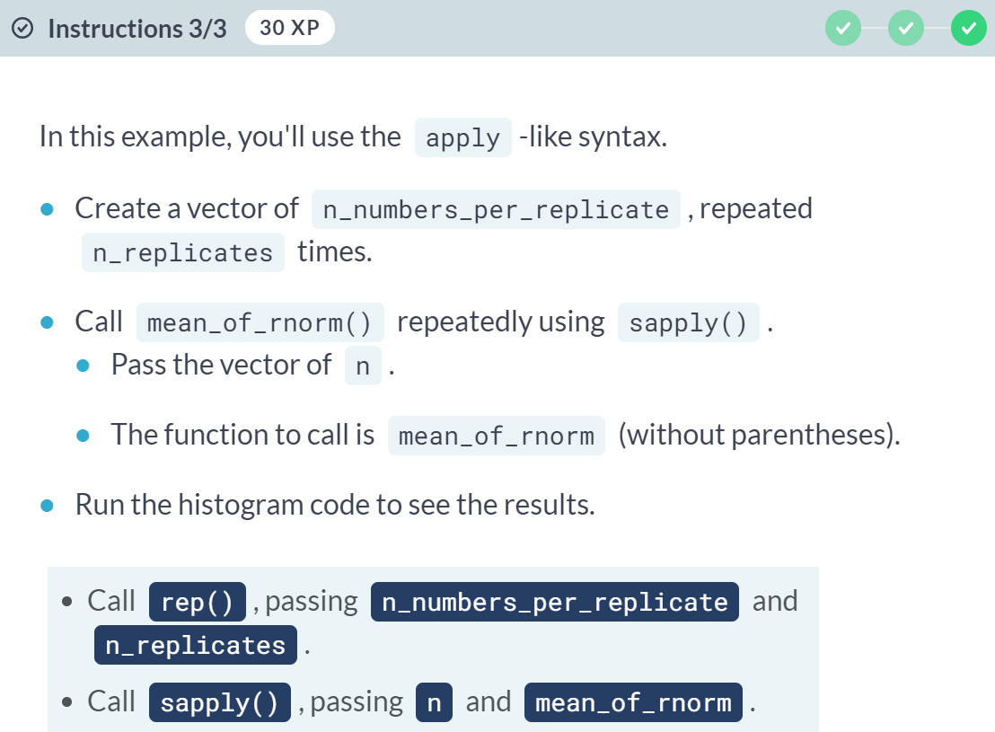

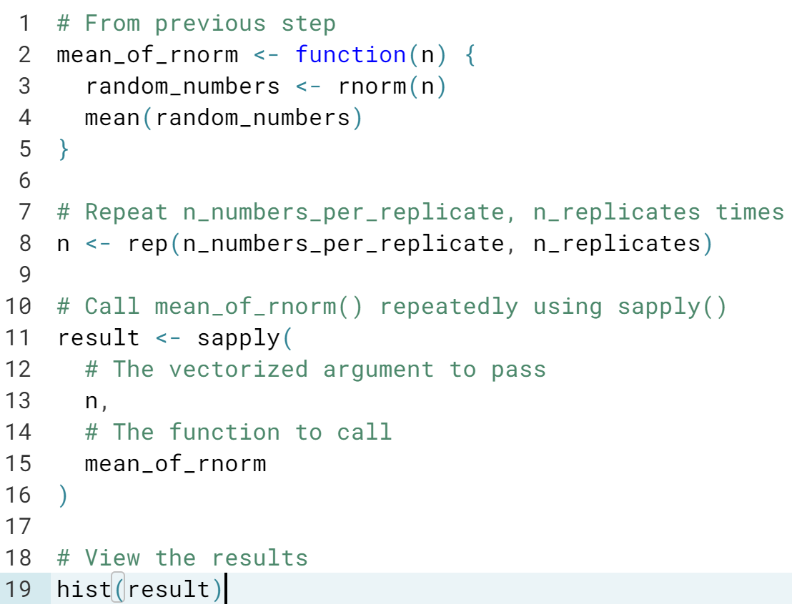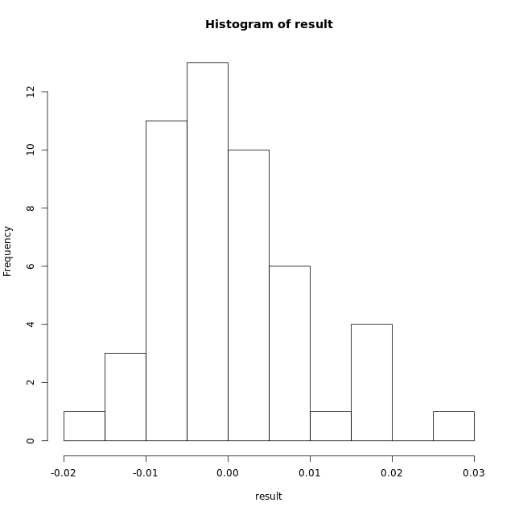

# Probabilistic projection of migration (setup)

We'll now introduce a demographic model to be used throughout the course. It projects net migration rates via an autoregressive model (AR1). It is a typical example of an embarrassingly parallel application where a set of estimated parameters is used repeatedly for prediction. In an AR1, a future value is dependent on the past value. The process has a long term mean (mu), a rate of convergence (phi) to mu, and an error term with standard deviation (sigma). You do not need to know details of the modelling.

We have simulated 1000 samples of these three parameters (dataset ar1est) and will use it to project the future distribution of migration rates. Starting from an initial rate (rate0), each row of ar1est can be used to generate a block of migration trajectories (using function ar1_block_of_trajectories()). This process is shown in the image below (where ar1_block_of_trajectories() is abbreviated with ar1_block()). Combining blocks from all rows gives the final migration distribution.

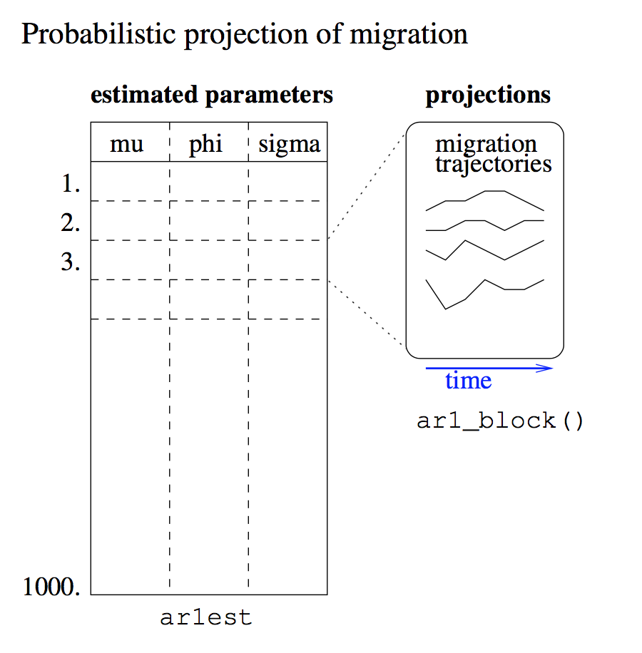

Your job in this exercise is to explore the function ar1_block_of_trajectories() (type ar1_block_of_trajectories in your console). Its argument id determines which row of ar1est to use. What type of object does the function return and what do the function arguments traj_len and block_size correspond to in the function output?



# Probabilistic projection of migration

Here, we'll continue the previous application. The 1000 sets of estimates in ar1est is a result of an estimation using migration data for the United States. The task is to project the future distribution of the US migration rate for 15 time points using the whole estimation dataset instead of just one row. You will generate a set of 10000 trajectories of length 15, each of which makes use of one parameter set, thus each parameter row is re-used 10 times. You will also visualize the results using a preloaded function show_migration().

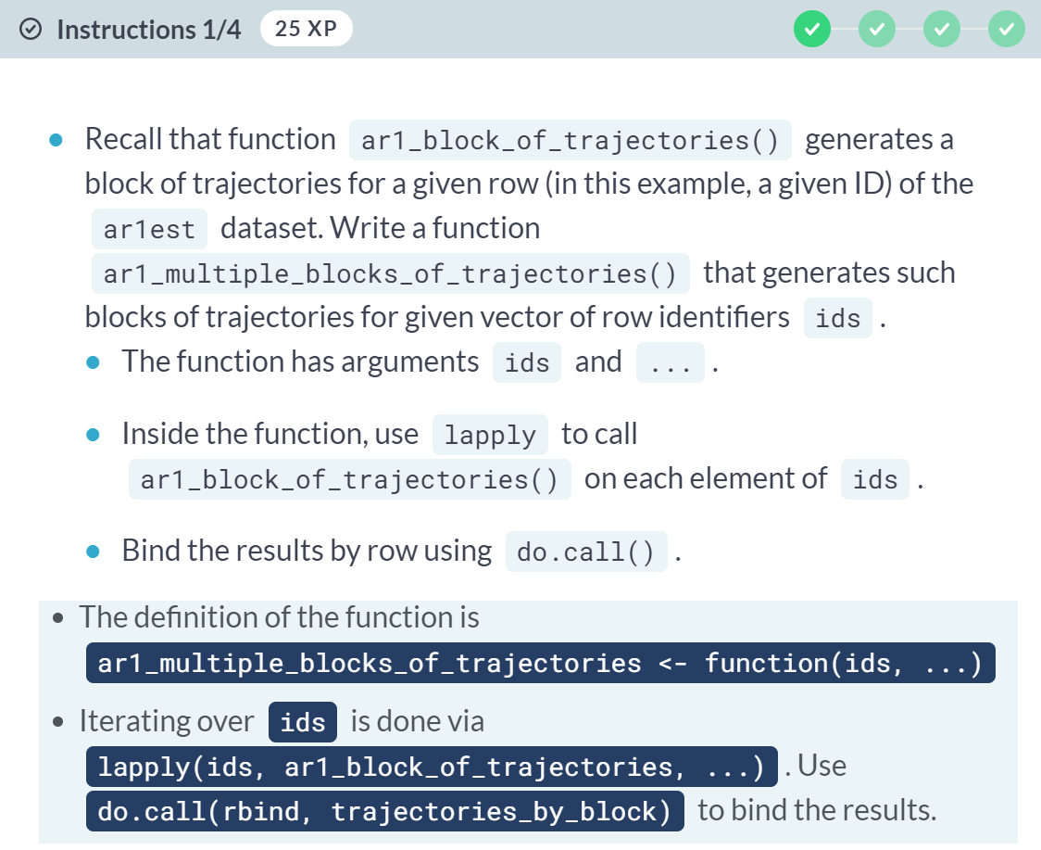

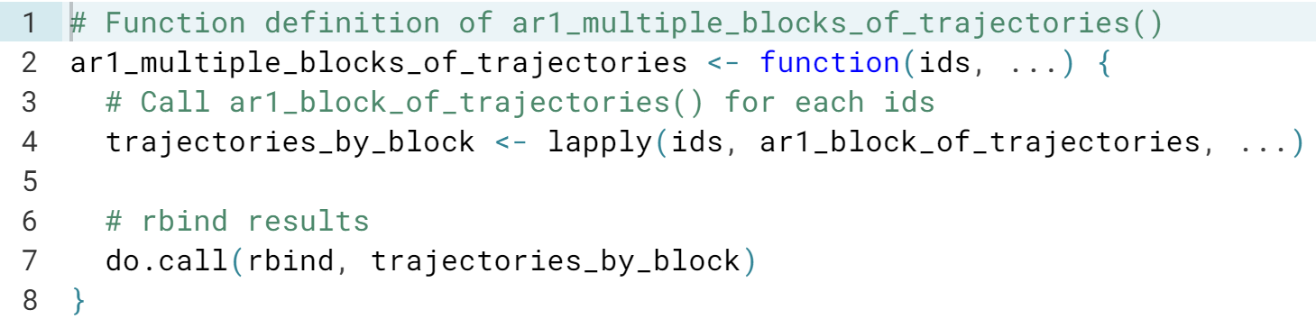  
(Exercise continues on the next page)

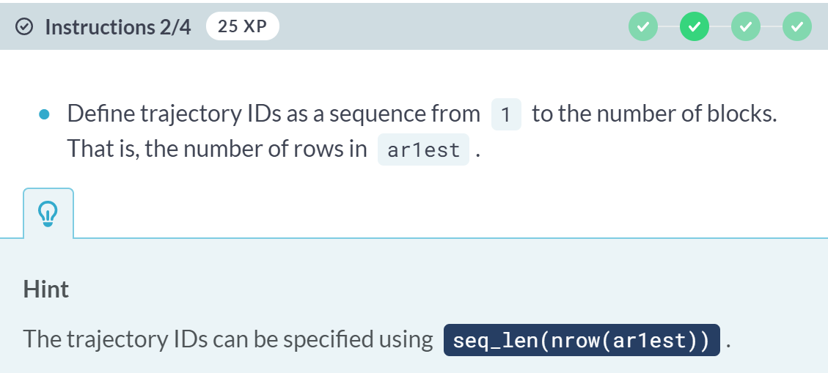

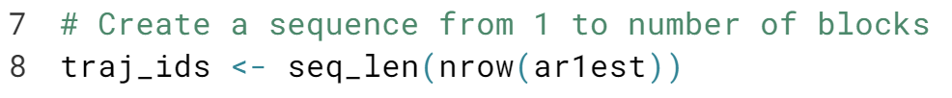

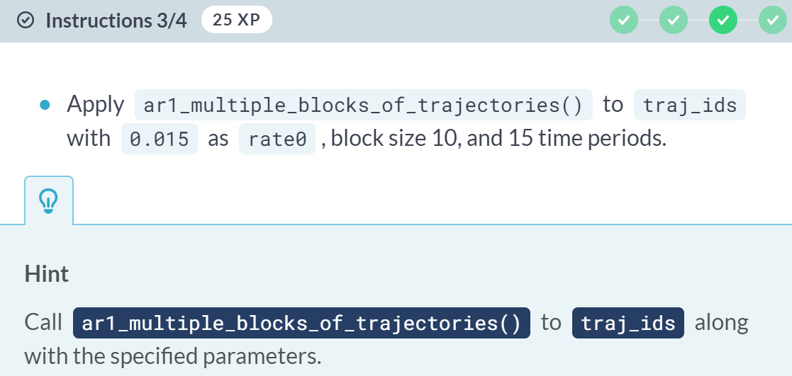

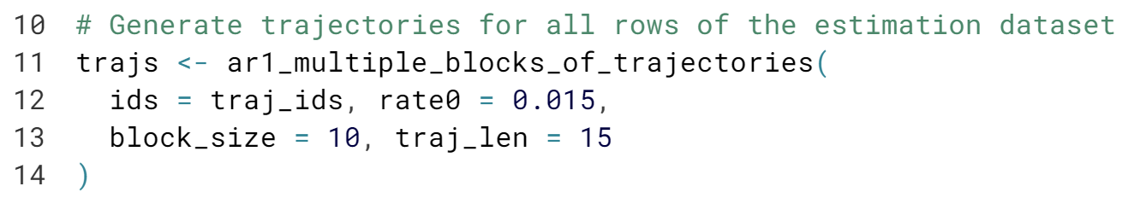

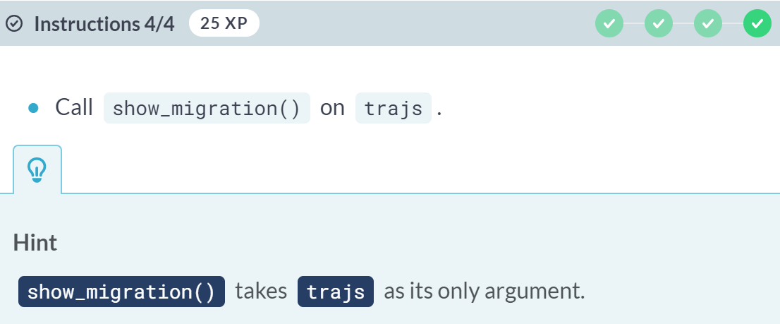

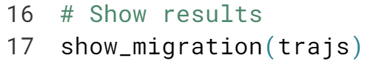

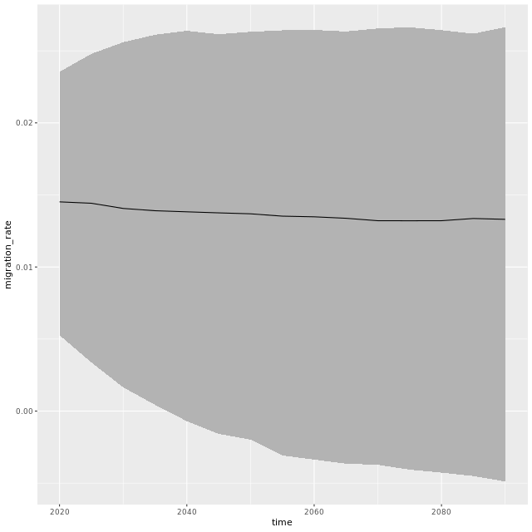

This is another typical example of an embarrassingly parallel application, here used in a forecasting model. You will soon see an example, which parallelize this simulation.

# Passing arguments via clusterApply()

We will use a similar example as in the last lesson where we evaluated rnorm() on a sequence c(4,3,2,1) in parallel, except this time you will pass additional arguments to rnorm(). These can be added to the clusterApply() function.

For comparison, you'll create a sequential solution using lapply() in Step 2 of this exercise and create a parallel solution in Step 3.

Even though computers have often more logical cores than physical cores, there is no speed advantage of running R processes on more than the number of physical cores.

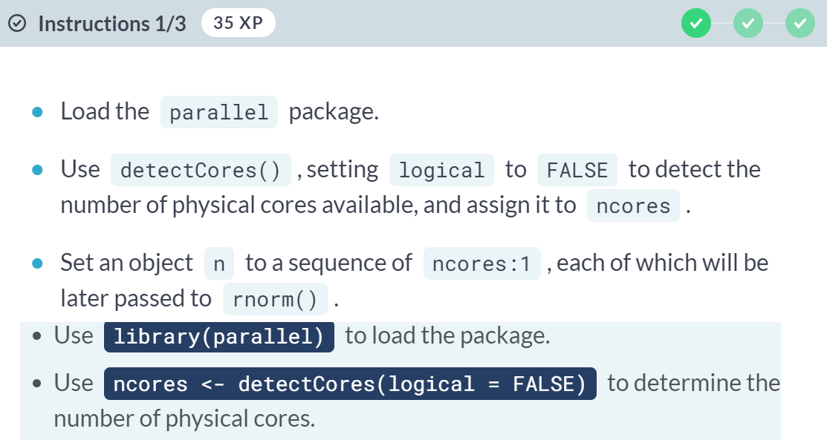

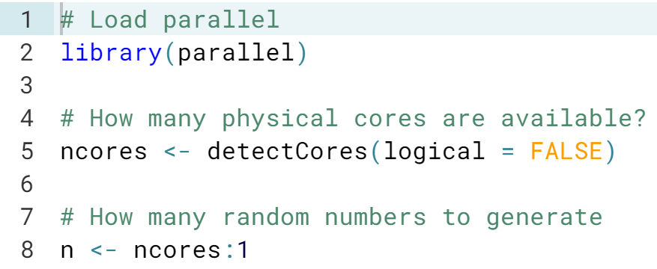  
(Exercise continues on the next page)

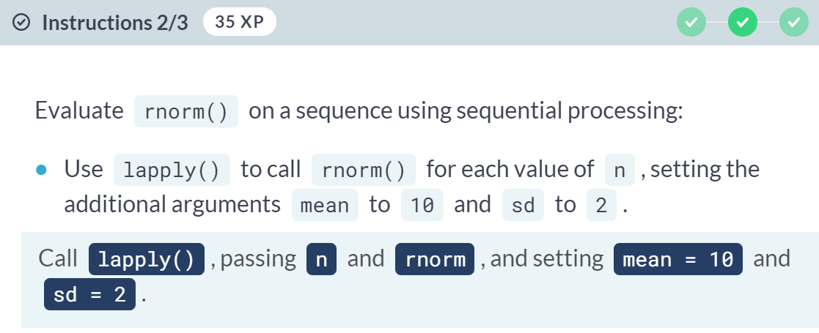

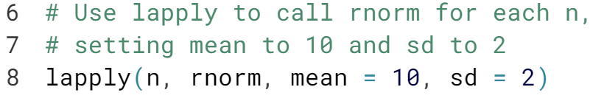

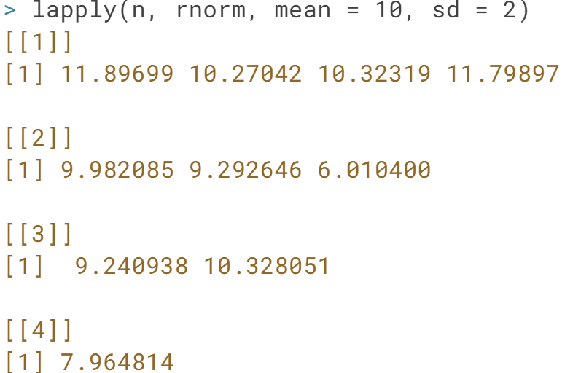

(Exercise continues on the next page)

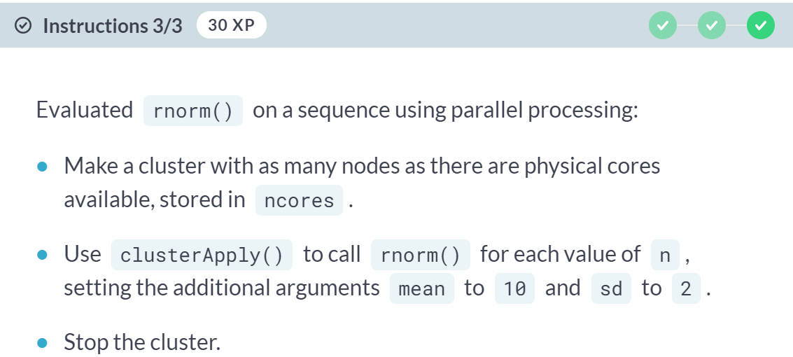

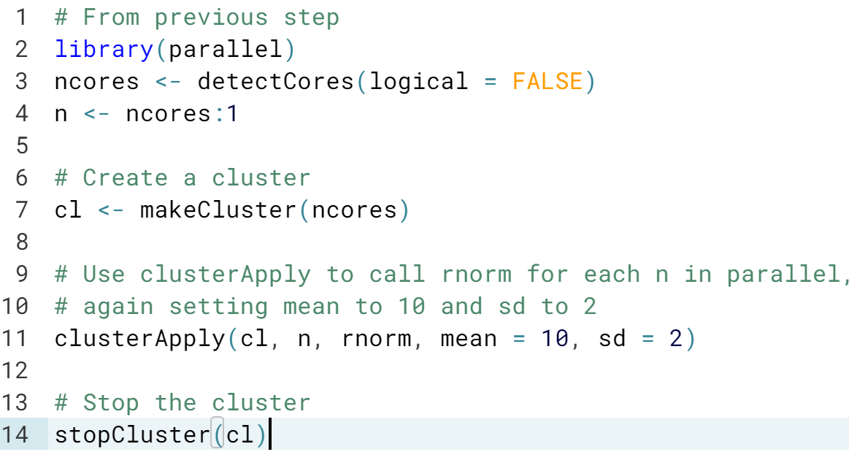

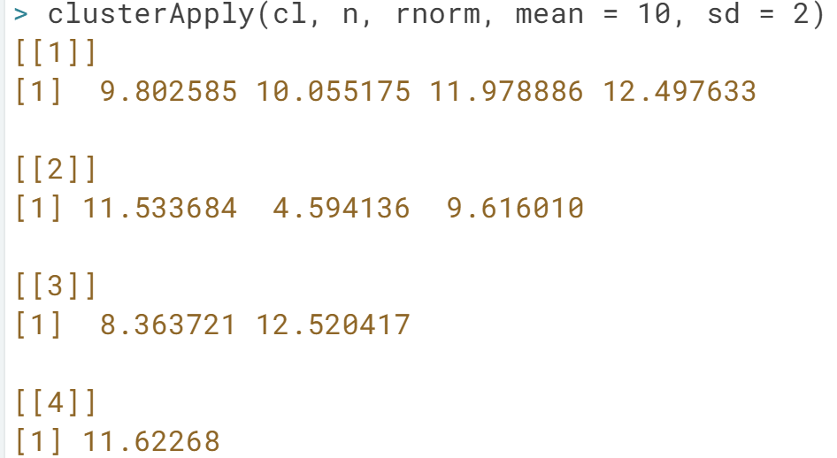

# Sum in parallel

In the first lesson, you learned how to split sum(1:100) into independent pieces. For two cores, you can do sum(1:50) + sum(51:100). Here, we'll implement this using clusterApply(). The parallel package is preloaded, as well as a cluster object cl with two workers.

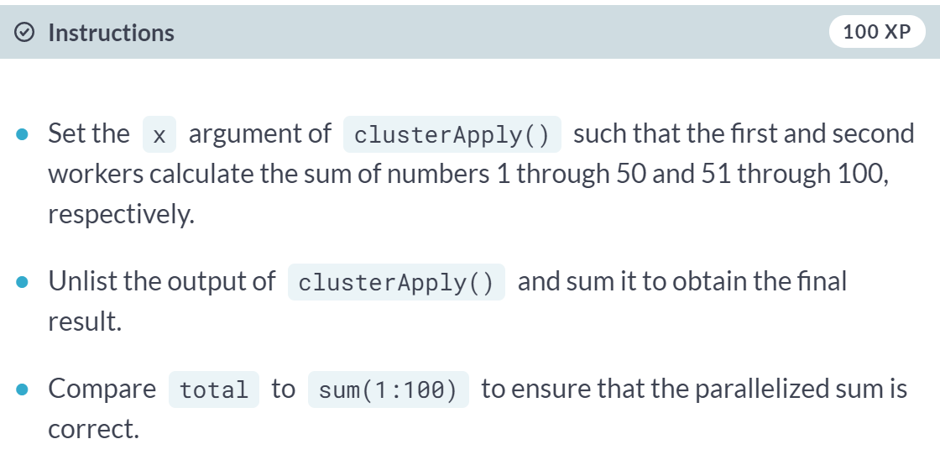

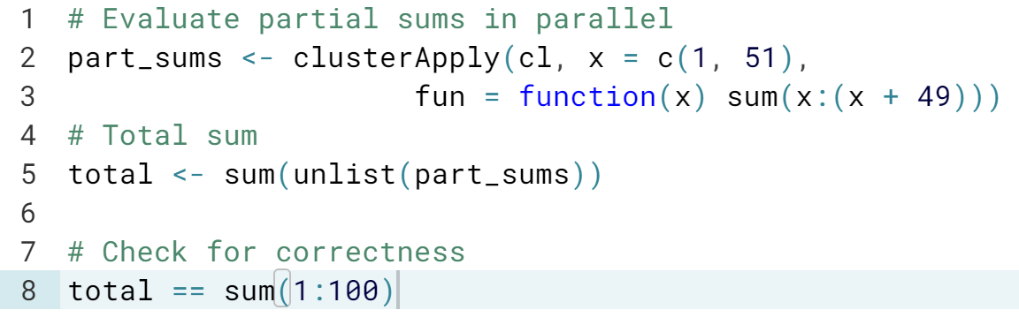

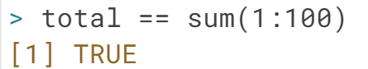

# More tasks than workers

You will now parallelize your simple embarrassingly parallel application from a previous exercise. To repeatedly evaluate mean_of_rnorm() that computes the mean of a set of random numbers, a sequential for-loop solution looks as follows:

for(iter in seq_len(n_replicates))

result[iter] <- mean_of_rnorm(n_numbers_per_replicate)

The iterations are independent of one another. Thus, we can convert it into a parallel form. Notice that we are now distributing many more tasks (namely n_replicates) than we have workers available.

The function mean_of_rnorm() is preloaded, as is the parallel library.

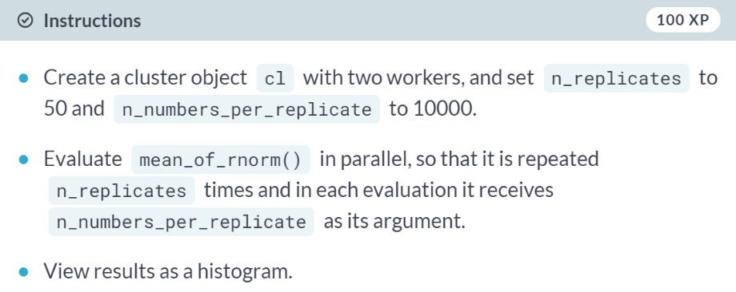  
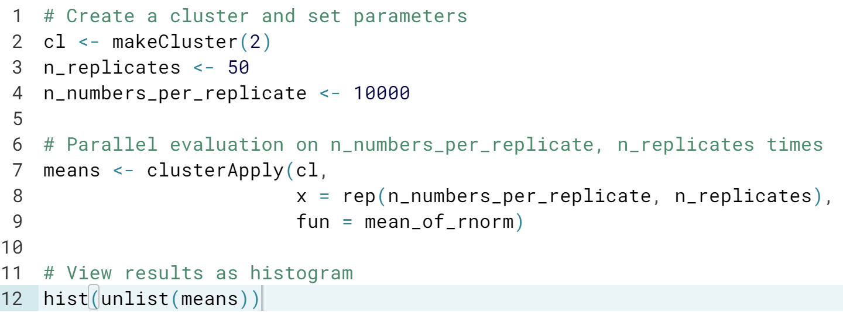  
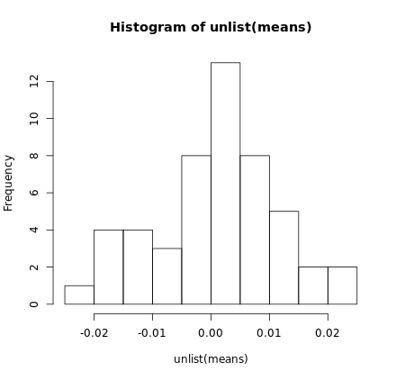

#### The parallel Package

#### This chapter will dive deeper into the parallel package. You'll learn about the various backends and their differences and get a deep understanding about the workhorse of the package, namely the clusterApply() function. Strategies for task segmentation including their pitfalls will also be discussed.

# Exploring the cluster object

In this exercise, you will explore the cluster object created by makeCluster(). In addition, you will use clusterCall(), which evaluates a given function on all workers. This can be useful, for example, when retrieving information from workers.

clusterCall() takes two arguments: the cluster object and the function to apply to each worker node. Just like lapply(), the function is passed without parentheses.

Here, we will use clusterCall() to determine the process ID of the workers, which is equivalent to finding process IDs of R sessions spawned by the master. Such info could be used for process management, including things outside of R.

#### 

#### 

#### 

#### 

#### 

#### Classy cluster creation! The cluster object you created has class SOCKcluster, and contained four worker nodes of class SOCKnode.

# Socket vs. Fork

Now we will explore differences between the socket and the fork backends. In a fork cluster, each worker is a copy of the master process, whereas socket workers start with an empty environment. We define a global object and check if workers have an access to it under each of the backends. Your job is to use the function clusterCall() to look for the global object in the workers' environment.

The package parallel and the print_global_var() function, which calls print(a_global_var), are available in your workspace.

#### 

#### 

#### 

#### (Exercise continues on the next page)

#### 

#### 

#### (Exercise continues on the next page)

#### 

#### 

#### 

#### 

#### Yes! Socket clusters are initialized without variables, so a_global_var was not found. Fork clusters take a copy of global variables, but changes made after the cluster is created are not copied to each node.

# Benchmarking setup

In this exercise, you will take the simple embarrassingly parallel application for computing mean of random numbers (mean_of_rnorm()) from the first chapter, and implement two functions: One that runs the application sequentially, mean_of_rnorm_sequentially(), and one that runs it in parallel, mean_of_rnorm_in_parallel(). We will then benchmark these two functions in the next exercise.

mean_of_rnorm() and a cluster object, cl, are defined.

#### 

#### 

#### (Exercise continues on the next page)

#### 

#### 

#### 

# Task size matters

Now you will benchmark the functions created in the previous exercise using the microbenchmark package. To see the impact of the parallel processing overhead, you will pass different number of replications and sample sizes and explore under which conditions parallel processing becomes inefficient.

mean_of_rnorm_sequentially(), mean_of_rnorm_in_parallel(), and a cluster cl with two nodes are available.

#### 

#### 

#### (Exercise continues on the next page)

#### 

#### 

#### 

#### Excellent! We saw a speed-up when the independent tasks were large and the communication overhead low. We saw a significant inefficiency when the sample size was small.

#### Note that the DataCamp servers have either two or four physical cores and its load depends on the level of current utilization. You can run these tests on your own computer, hopefully with more cores, and you should see a larger speed-up.

# Loading package on nodes

In this example, you will run a simple application in parallel that requires the package extraDistr. You will see that if you load it only on the master, the code will fail. Then you will use the function clusterEvalQ() to load the package on all cluster nodes.

The parallel package and a 4-node cluster object cl with socket backend is available in your workspace. You will use a pre-defined function myrdnorm() that takes n, mean, and sd as arguments and passes it to the rdnorm() function from extraDistr to generate n random numbers from the discrete normal distribution with given mean and standard deviation.

#### 

#### 

#### (Exercise continues on the next page)

#### 

#### 

#### 

#### Bravo! You've seen that loading a package on the master of a socket cluster does not imply that workers have access to its functions. They need to be initialized with the package first.

# Setting global variables

Here you will use a slight modification of the previous example, where instead of passing the mean and sd parameters as arguments, they will be defined in the worker's environment as global variables. You will use the clusterEvalQ() function again for the worker initialization.

As before, the parallel package and the cluster object cl are available in your workspace. A variant of myrdnorm() that uses global variables is shown in the script.

#### 

#### 

#### (More data below…)

#### (Exercise continues on the next page)

#### 

#### (Results on the next page)

#### 

#### 

#### Well done! *clusterEvalQ()* is one way to initialize workers before the actual parallel computation.

# Exporting global objects

Using clusterEvalQ() for setting global variables as in the last example assigns them only on the nodes and not on the master. If you want to share the same objects between master and the nodes, use the function clusterExport(). Here we use the same function as in the last exercise, myrdnorm() and initialize the global objects first on the master. Then you will use clusterExport() to export those objects to the workers.

clusterExport() takes two arguments: a cluster object and a character vector of variable names to copy from the master to the nodes.

The parallel package, a cluster object of size four, cl, the function myrdnorm(), and the number of numbers to generate, n, are available.

#### 

#### 

#### 

#### 

#### Excellent! You are a master in using *clusterEvalQ()* and *clusterExport()* to get workers ready for their actual work. Note that *clusterExport()* can be used to export any object, including functions.

# Passing data as arguments

Here, we will explore subsetting data by passing it to workers as arguments. We will use the Jane Austen example introduced previously. The goal is to find unique words within the 6 books from the janeaustenr package, that start with the given letter, here "v", and have the given number of characters or more, here at least 10. You will evaluate the task in parallel on a cluster of size 2. You will also split the set of words into 2 subsets so that each worker gets one of them.

The parallel package, the set of words extracted from janeaustenr, and a cluster object cl with 2 workers are available in your workspace. The function with the following arguments has also been defined for you:

select_words(words, letter, min_length)

select_words() extracts all words that start with letter and are of length min_length or more. Run the function in the console to see how it works.

#### 

#### 

#### 

#### 

#### 

#### 

#### 

#### 

#### Fantastic! You learned how to pass chunked data to workers via arguments.

# Chunking migration application on worker's side

The migration application from the first chapter is an example of the third type of chunking, namely when the workers "see" the whole dataset and only get instructions which part of the data to work on. Here, you will parallelize the code. Earlier you defined a function ar1_multiple_blocks_of_trajectories() that takes a vector of row identifiers as an argument and generates migration trajectories using the corresponding rows of the parameter set ar1est.

ar1_multiple_blocks_of_trajectories() depends on ar1_block_of_trajectories() which in turn depends on ar1_one_trajectory(). These functions along with the cluster object cl of size 4, function show_migration(), the dataset ar1est (reduced to 200 rows) and packages parallel and ggplot2 are available in your workspace.

#### 

#### 

#### 

#### 

#### 

#### 

#### 

#### Fabulous! You mastered the difference between workers getting their data via arguments and the case when workers have a knowledge about all data and know which part to work on.

# Alternative chunking

We will now slightly modify the application of chunking in the previous exercise. Instead of a task corresponding to one row, each task will now process 40 rows, which corresponds to 5 tasks in total. You will then compare the shape of the returned object to the one you created in the last exercise. Recall that in both cases you are generating 10 trajectories per each of the 200 rows, which is 2000 trajectories in total, each 15 time points long.

The package parallel and cluster object cl with 4 workers along with all dependent functions and dataset have been exported to the workers. The object res returned by clusterApply() in the previous exercise is also in your workspace, now called res_prev.

#### 

#### 

#### 

#### The number of tasks in the two exercises was 200 and 5, respectively, generating 200 x 1 x 10 versus 5 x 40 x 10 trajectories, i.e. 2000 in both cases.

#### foreach, future.apply and Load Balancing

#### In this chapter, you will look at two user-contributed packages, namely foreach and future.apply, which make parallel programming in R even easier. They are built on top of the parallel and future packages. In the last lesson of this chapter, you will learn about the advantages and pitfalls of load balancing and scheduling.

# Combining results

The foreach() function returns a list by default. One can convert results to a different format via arguments passed to foreach(). What argument should be passed in the code below so that the length corresponds to the output below? The foreach package is loaded in your namespace.

set.seed(1)

n.seq <- sample(1:1000, 10)

res <- foreach(n = n.seq, ___) %do% rnorm(n)

length(res)

[1] 5495

#### 

#### Yes! Results are combined into a vector using the c function.

# Word frequency with foreach

Recall the first chapter where you found the most frequent words from the janeaustenr package that are of certain minimum length. It looked like this:

result <- lapply(letters, max_frequency,

words = words, min_length = 5) %>% unlist

In this exercise, you will implement the foreach construct to solve the same problem.

The janeaustenr package, a vector of all words from the included books, words, and a function max_frequency() for finding the results based on a given starting letter are all available in your workspace.

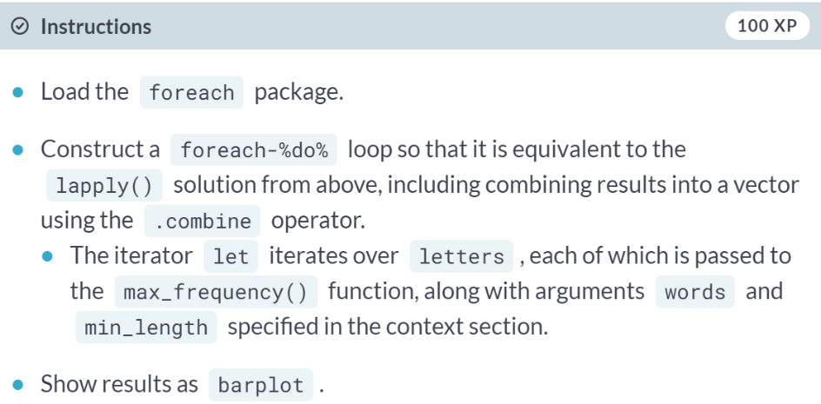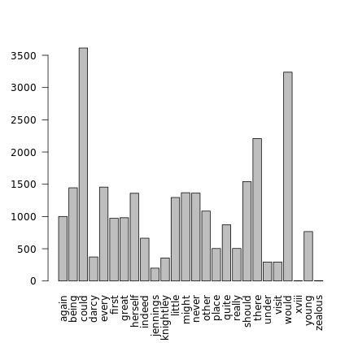

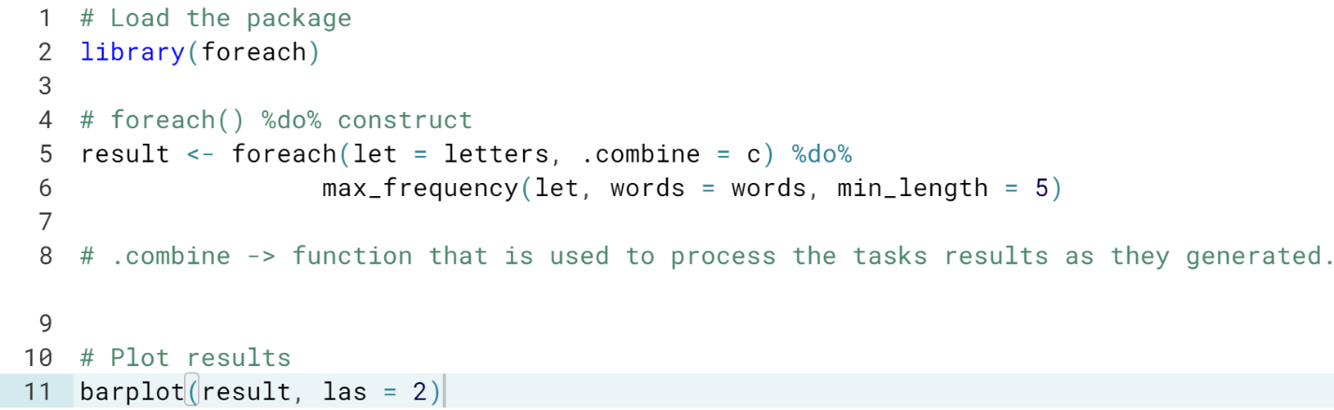

# Multiple iterators in word frequency

This exercise is a modification of the previous one. Now assume you want to vary the minimum word length across the letters of the alphabet. Specifically, your job is to modify the code so that the maximum frequency for the first half of the alphabet is obtained for words that are two and more characters long, while the frequency corresponding to the second half of the alphabet is derived from words that are six and more characters long. Note that we are using an alphabet of 26 characters.

Your namespace has all the objects from the previous exercise, plus the foreach package is loaded.

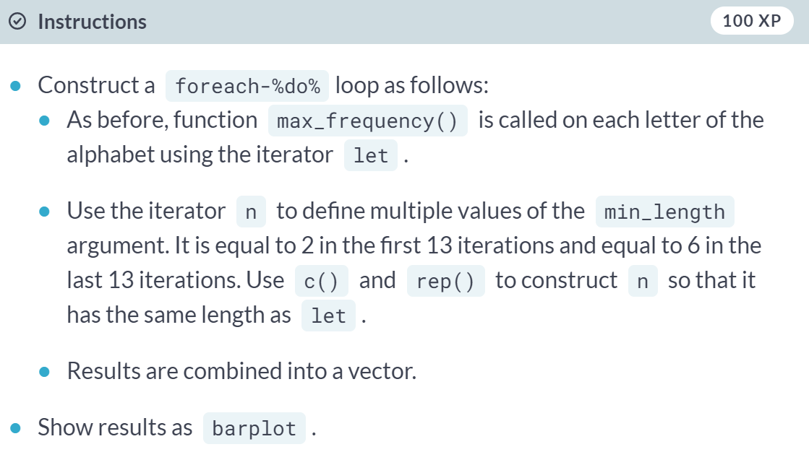

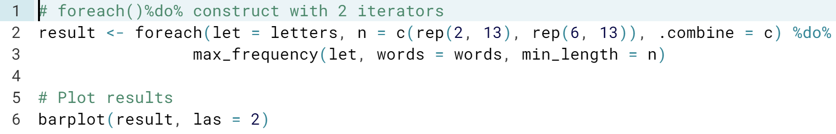

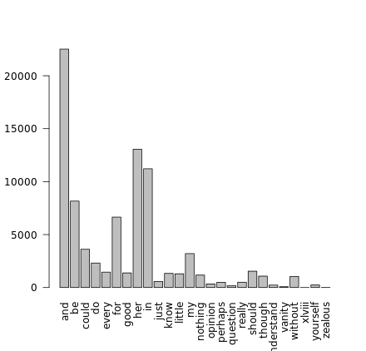

# Using doParallel

In one of the previous exercises, you parallelized the function myrdnorm() which uses the package extraDistr to generate discrete random numbers. Here you will implement a parallel foreach solution to the same problem, using the doParallel backend. doParallel provides an argument .packages which ensures that external packages are loaded on all nodes.

doParallel and the function myrdnorm() are loaded in your namespace.

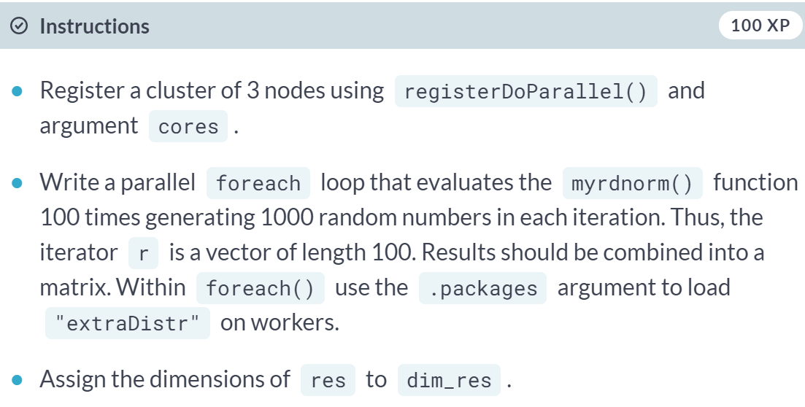

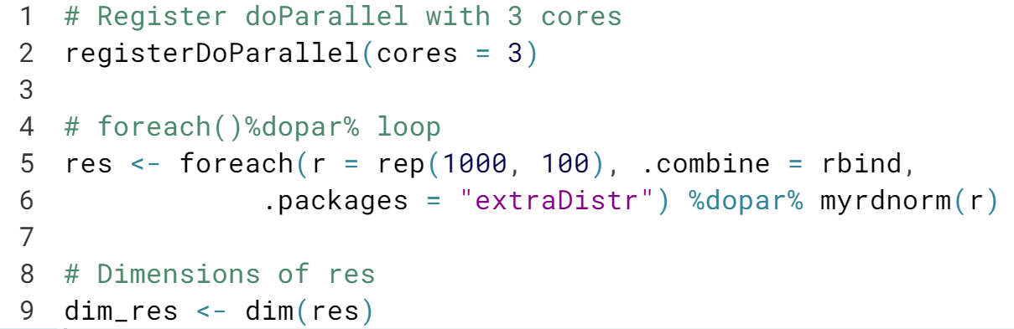

Excellent! Another useful option in addition to ***.packages*** is ***.export*** for exporting objects from master to workers. We will use it in the next exercise.

# Word frequency with doParallel

So far you learned how to search for the most frequent word in a text sequentially using foreach(). In the course of the next two exercises, you will implement the same task using doParallel and doFuture for parallel processing and benchmark it against the sequential version.

The sequential solution is implemented in function freq_seq() (type freq_seq in your console to see it). It iterates over a global character vector chars and calls the function max_frequency() which searches within a vector of words, while filtering for minimum word length. All these objects are preloaded, as is the doParallel package. Your job now is to write a function freq_doPar() that runs the same code in parallel via doParallel.

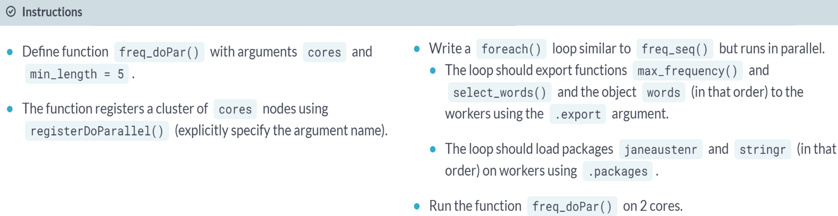  
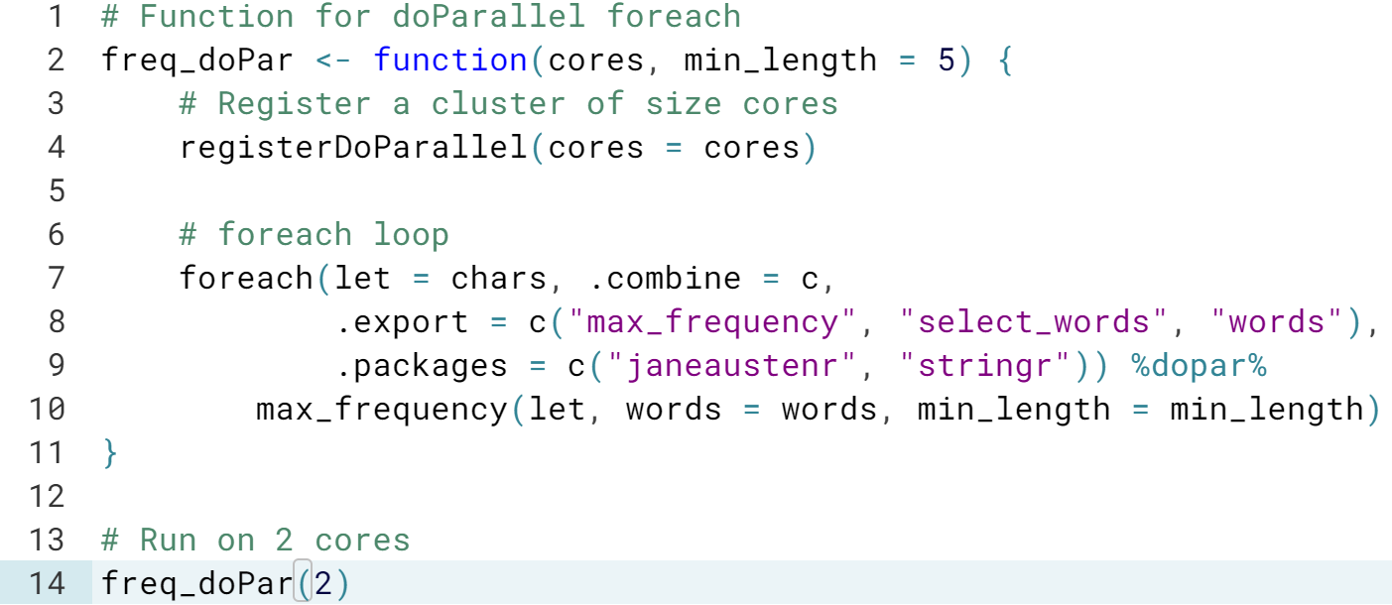  
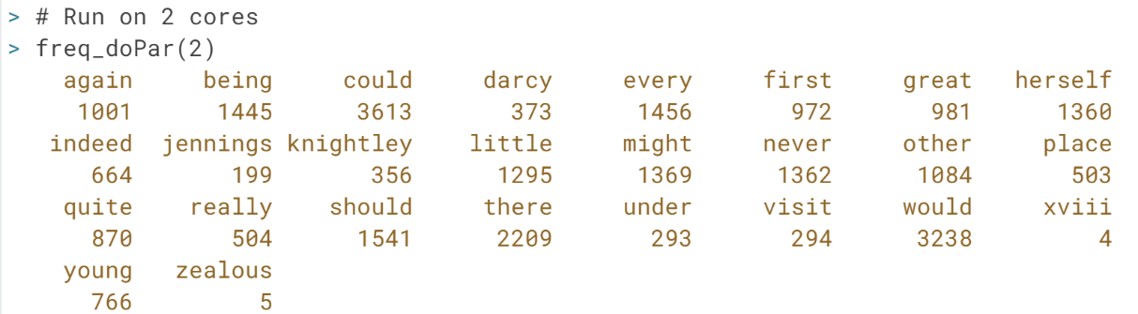

# Word frequency with doFuture and benchmarking

Now your job is to create a function freq_doFut() that accomplishes the same task as freq_doPar() but with the doFuture backend. Note that when using doFuture, arguments .packages and .export in foreach() are not necessary, as the package deals with the exports automatically.

You will then benchmark these two functions, together with the sequential freq_seq(). All the functions from the last exercise are available in your workspace. In addition, the packages doFuture and microbenchmark are also preloaded. To keep the computation time low, the global chars vector is set to the first six letters of the alphabet only.

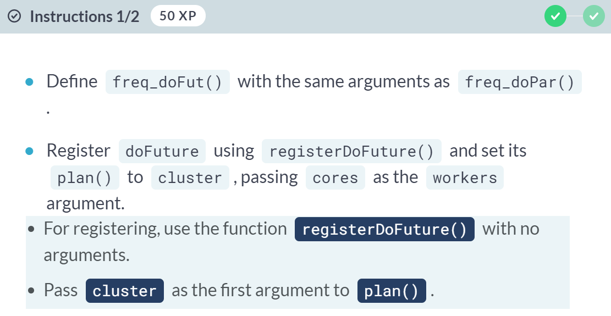

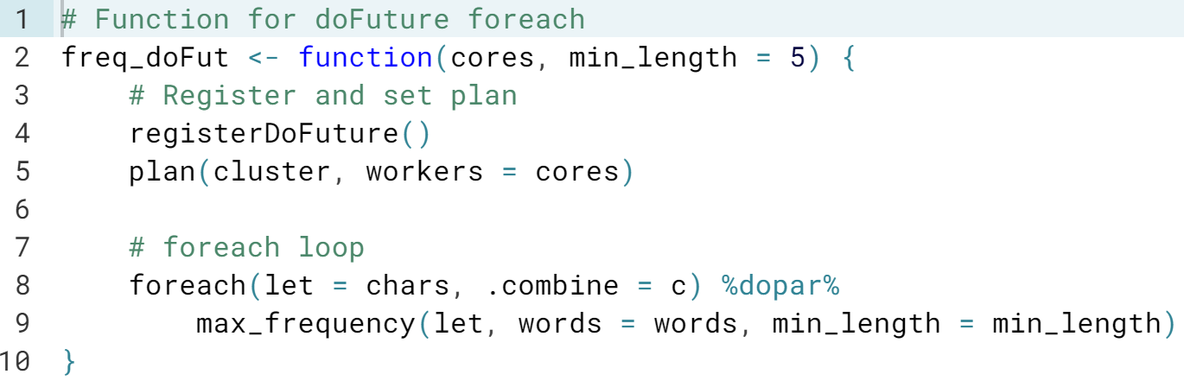

#### (Exercise continues on the next page)

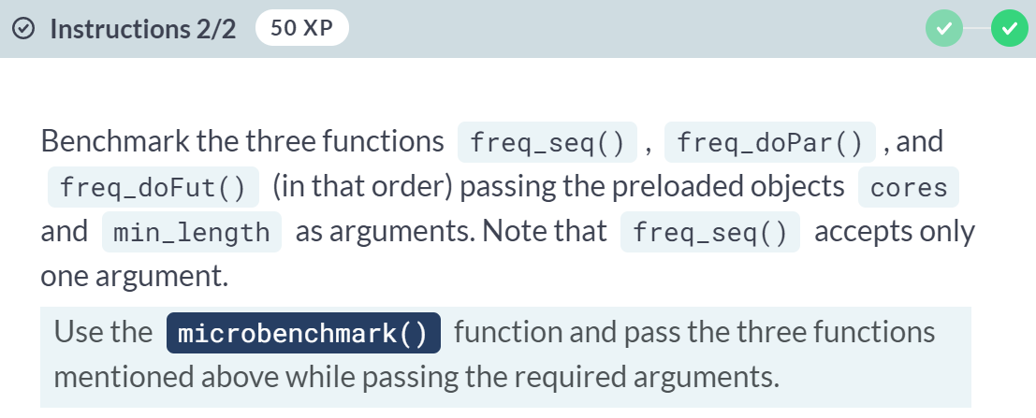

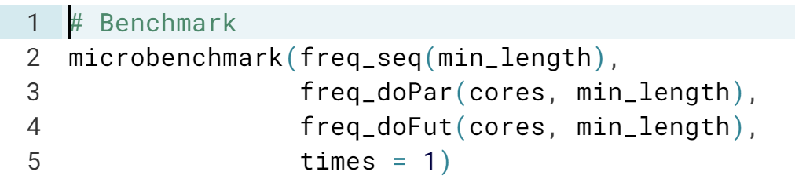

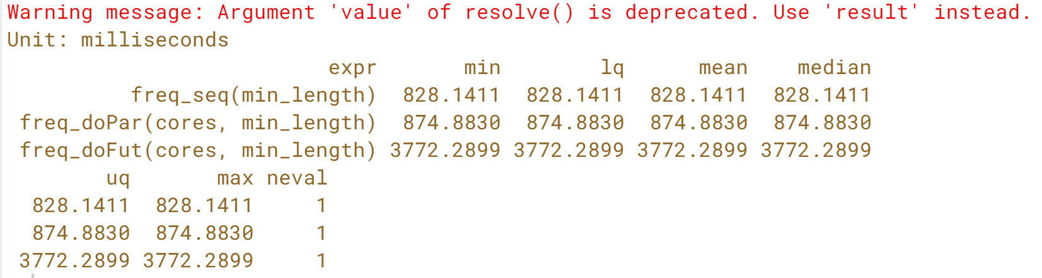

Fantastic! It is straight forward to swap parallel backends with foreach. In this small example, you might not see any time advantage in running it in parallel. In addition, doFuture is usually somewhat slower than doParallel.

This is because doFuture has a higher computation overhead. We encourage you to test these frameworks on more time-consuming applications where an overhead become negligible relative to the overall processing time.

# Word frequency with future.apply

In the spirit of the last slide, imagine you are a package developer. You will now code the main function of your package, a function that for each given letter finds the maximum frequency in a set of words that starts with that letter and is at least a given length long. It is the same task as in our last exercise, except that now you will use the future.apply package and apply it to the Barack Obama’s State of the Union address in 2016.

The package future.apply and functions max_frequency() and extract_words_from_text() are available in your workspace. The dataset is called obama_speech.

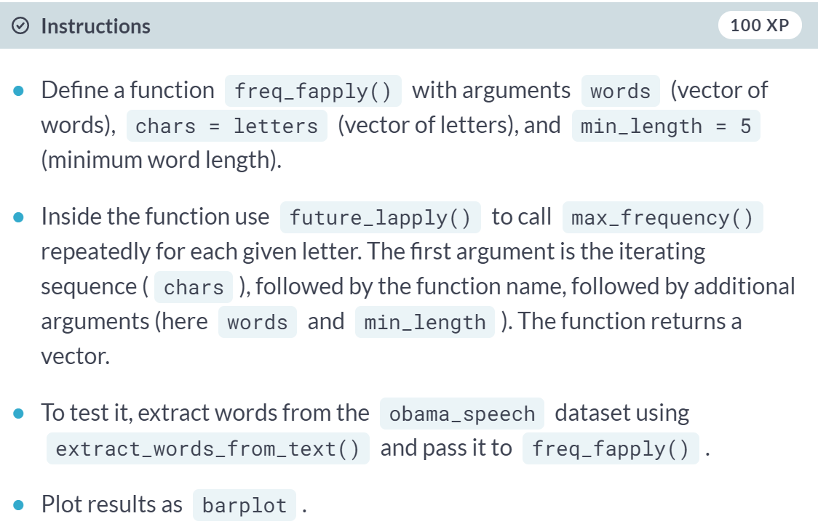  
  
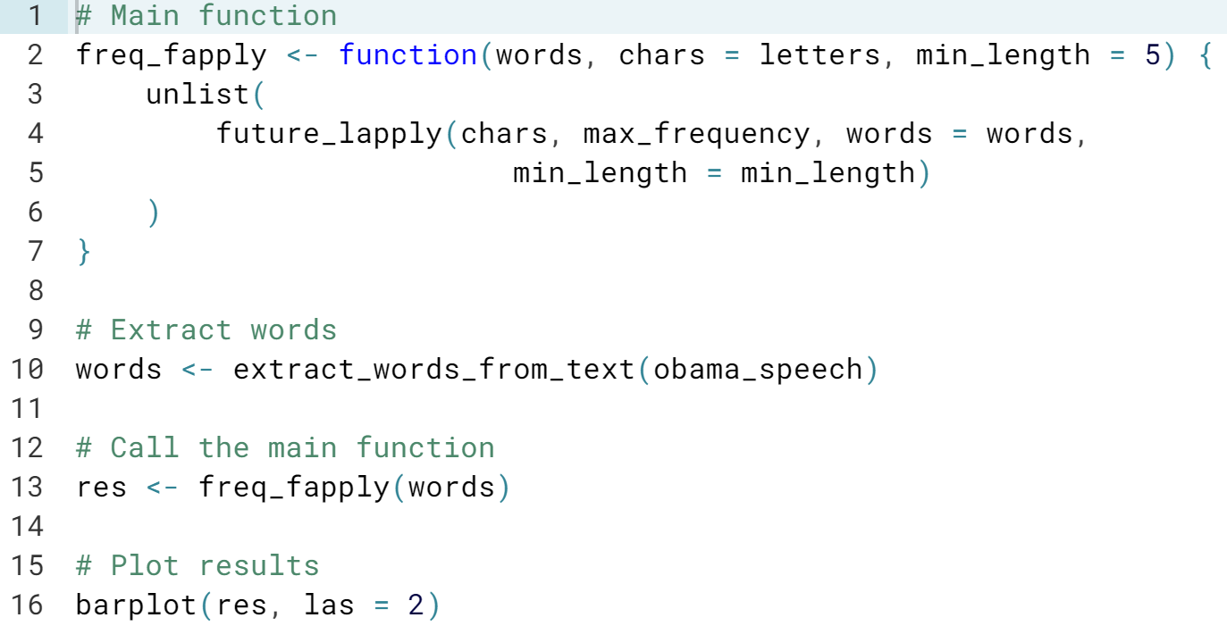  
(plot on the next page)

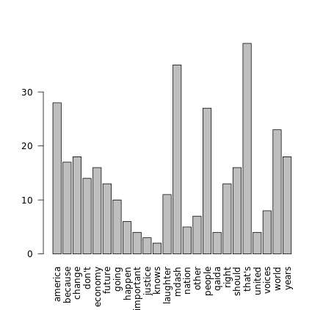

# Planning future

Now imagine you are a user of the fictional package from the previous exercise. At home you have a two-CPU Mac computer, and at work you use a Linux cluster with two 16-CPU computers, called "oisin" and "oscar". Your job is to write a function for each of the hardware that calls freq_fapply() while taking advantage of all available CPUs. For the cluster, you set workers to a vector of computer names corresponding to the number of CPUs, i.e. 16 x "oisin" and 16 x "oscar". For a one-CPU environment, we have created a function fapply_seq().

All objects from the last exercise are loaded, including words and chars which the new functions assume to be global variables. Both functions will use ... and pass it to freq_fapply() for additional arguments.

#### 

#### 

#### Passing computer names into the cluster plan is a way of creating a cluster across multiple computers.

# Benchmark future

You will now benchmark the three functions, fapply_seq(), fapply_mc(), and fapply_cl(), while passing different numbers of cores. Note that since there are no "oisin" and "oscar" servers, instead of passing computer names to fapply_cl() we will simply use the number of nodes. The timing depends on the current load of the DataCamp server. However, for a small number of tasks, one function will be much slower than others. All objects from the two previous exercises are available in your workspace.

Note: Multicore does not work on Windows. We recommend using the 'multiprocess' or 'cluster' plan on Windows computers.

#### 

#### 

#### 

#### 

#### 

#### Fabulous! In this case, the length of chars was very small (26). If you increase the length of chars significantly (say 5000), you will notice that the sequential code (fapply_seq) is much slower.

#### This is because for a small number of tasks a sequential code can run faster than a parallel version due to the parallel overhead. The cluster plan has usually the largest overhead and thus, should be used only for larger number of tasks.

#### The multicore may be more efficient when the number of workers is equal to the number of cores. It uses shared memory, and thus is faster than cluster.

# Load balancing

You will now test the effect of load balancing in a situation with uneven task processing times. We create such situation by applying the sleep function on the workers side to a heterogeneous set of run times.

In your workspace there is a vector tasktime containing simulated processing times of 30 tasks (generated using runif()). There is also a cluster object cl with two nodes.

Your job is to apply the function Sys.sleep() to tasktime in parallel using clusterApply() and clusterApplyLB() and benchmark them. The parallel and microbenchmark packages are loaded. We also provided functions for plotting cluster usage plots called plot_cluster_apply() and plot_cluster_applyLB(). Both functions use functionality from the snow package.

#### 

#### 

#### 

#### 

# Scheduling

Now we compare the results from the previous exercise with ones generated using parSapply(), which represents here an implementation that groups tasks into as many chunks as there are workers available. You first explore its cluster usage plot, using the function plot_parSapply() we defined for you. We generated a version of the tasktime vector, called bias_tasktime that generates very uneven load. Your job is to compare the run times of parSapply() with clusterApplyLB() applied to bias_tasktime.

All objects from the previous exercise are in your workspace.

#### 

#### 

#### 

#### 

#### Excellent! The function *parSapply()* minimizes the communication by creating one chunk per worker. However, when there is an uneven task load, load balancing can be more efficient.

#### Random Numbers and Reproducibility

#### Now you might ask, can I reproduce my results if the application uses random numbers? Can I generate the same results regardless of if the code runs sequentially or in parallel? This chapter will answer these questions. You will learn about a random number generator well suited to a parallel environment and how the various packages make use of it.

# Reproducibility (I)

We ran the following code in your workspace:

library(doParallel)

cl.sock <- makeCluster(2, type = "PSOCK")

registerDoParallel(cl.sock)

Is the following code reproducible and why?

set.seed(100)

foreach (i = 1:2) %dopar% rnorm(3)

#### 

#### Correct! The nodes do not know about the RNG status on the master process.

# SOCK vs. FORK

In addition to the code in the previous exercise, we also created a FORK cluster for you.

cl.fork <- makeCluster(2, type = "FORK")

Your job is to register the two cluster objects with the preloaded doParallel package and compare results obtained with parallel foreach. How do the results differ in terms of reproducibility?

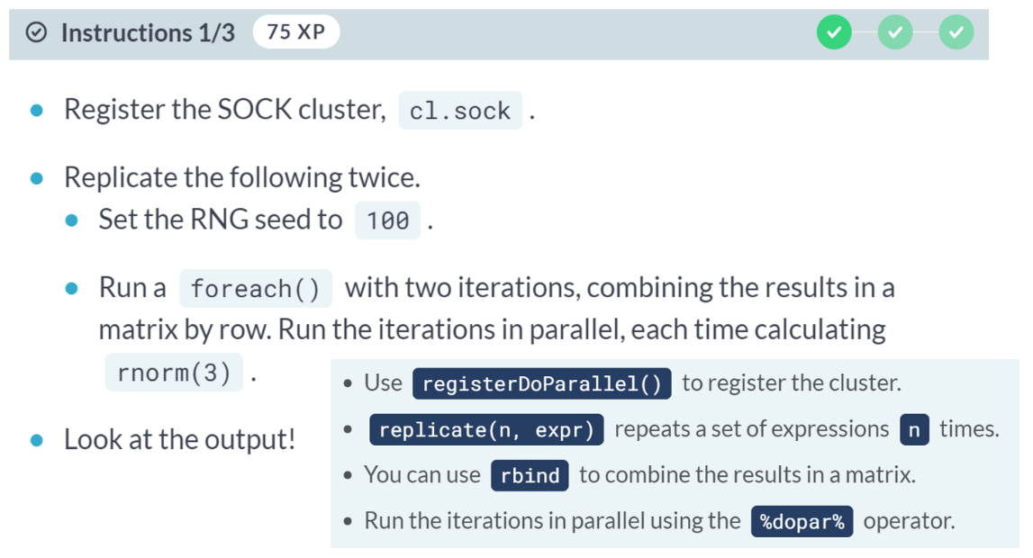

#### 

#### (Exercise continues on the next page)

#### 

#### 

#### (Exercise continues on the next page)

#### 

#### Excellent! All workers produce the same random numbers since they all are seeded with 100.

# Setting an RNG

In this exercise, you will look at the impact of the clusterSetRNGStream() function by checking the RNG kind before and after the RNG initialization.

clusterSetRNGStream() takes two arguments: a cluster object, and an integer for the random seed.

parallel is loaded in your workspace.

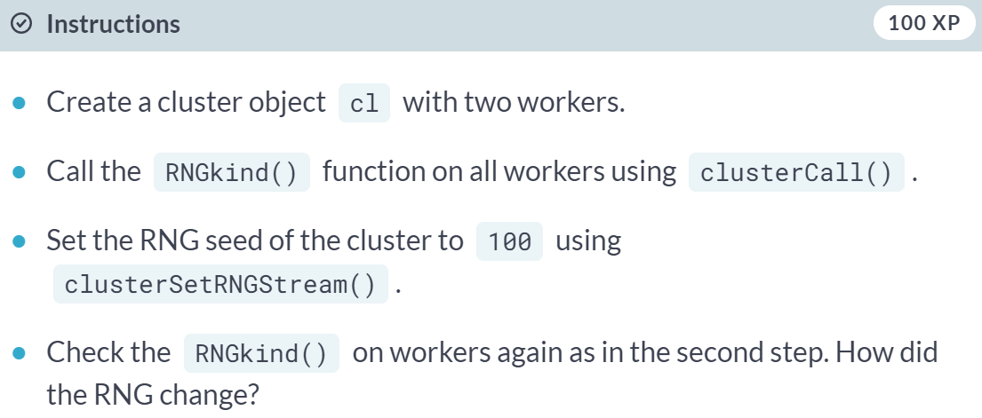

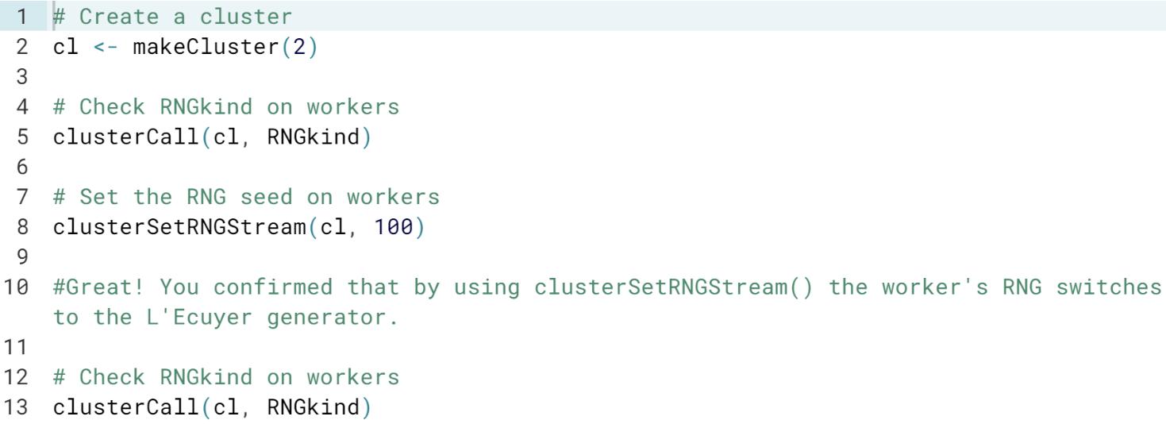

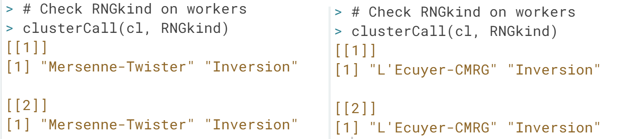

You confirmed that by using ***clusterSetRNGStream()*** the worker's RNG switches to the L'Ecuyer generator.

# Reproducible results in parallel

Now you are ready to make your results reproducible. You will use the simple embarrassingly parallel application for computing a mean of random numbers, mean_of_rnorm(), which we parallelized in the second chapter using clusterApply().

The parallel package, mean_of_rnorm(), n_vec (vector of sample sizes of 1000 replicated 5 times) are available in your workspace. You will now call clusterApply() repeatedly to check if results can be reproduced, without and with initializing the RNG.

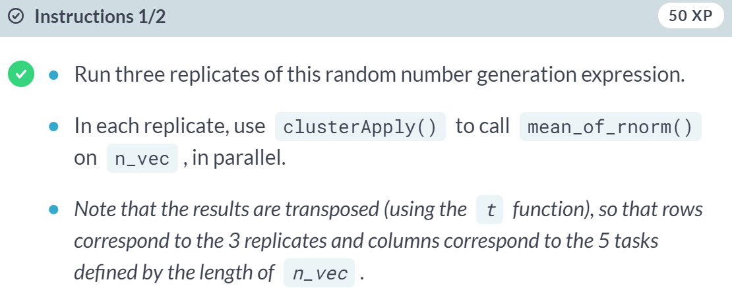  
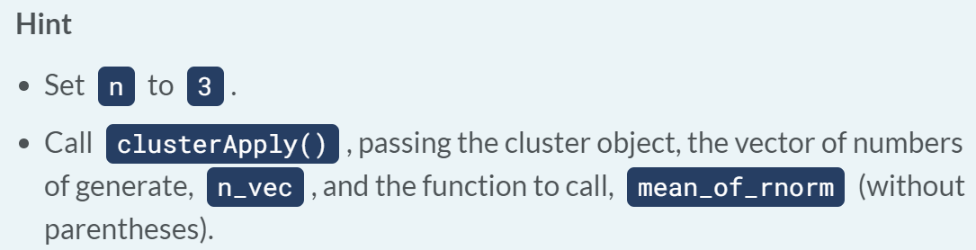

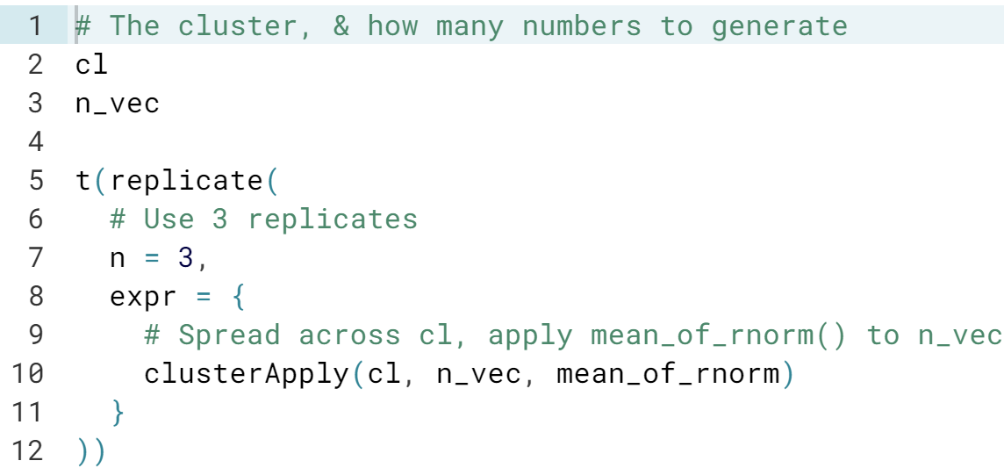  
  
(Result on the next page)

#### (Exercise continues on the next page)

#### 

#### 

#### 

#### Excellent! You're a champion in reproducing results with the parallel package.

# Non-reproducible results in parallel

Now we know that we can make results reproducible, so let's look at a situation when we cannot do so. We will run the previous example on clusters of different sizes, once on a cluster with two workers and on a cluster with four workers. Again, the parallel package, mean_of_rnorm(), and n_vec, are in your workspace.

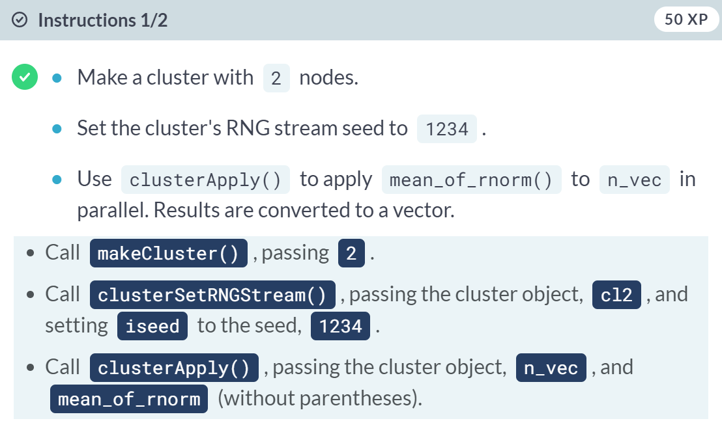

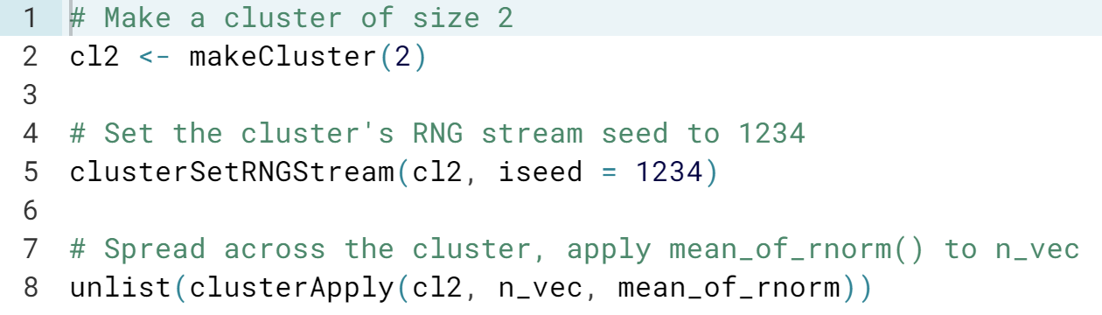



(Exercise continues on the next page)

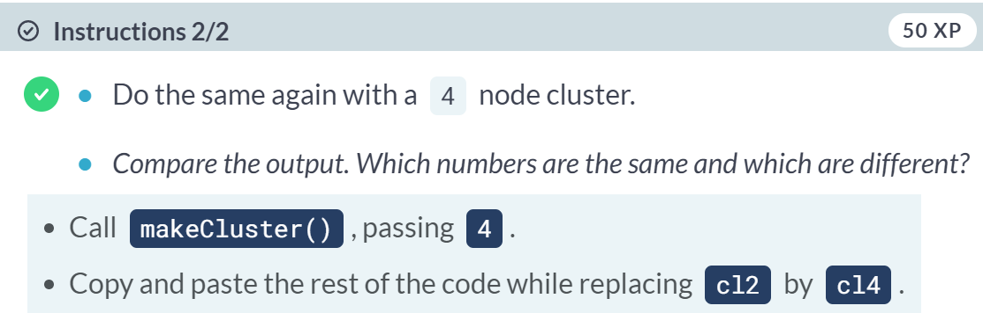

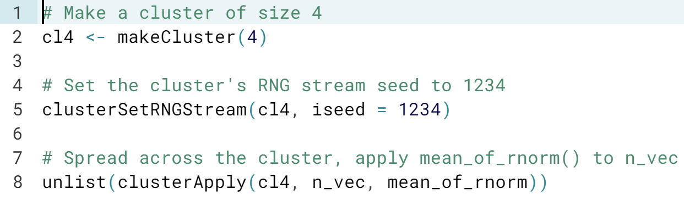



You got it! The first two numbers are the same, but after that they diverge because they are being evaluated on different cores.

In the parallel package results cannot be reproduced when processed on clusters of different sizes, because each worker is associated with one stream of random numbers.

Similarly, you won't be able to reproduce results when using ***clusterApplyLB().***

# Reproducibility (II)

We will slightly modify the first exercise of this chapter and ask the same question. We ran the following code in your workspace:

library(doParallel)

library(doRNG)

cl <- makeCluster(2)

registerDoParallel(cl)

registerDoRNG(100)

Is the following code reproducible on a cluster of any size and why?

set.seed(100)

res <- foreach (i = 1:3) %dopar% rnorm(3)

Fabulous! By using one stream per replication, results can be reproduced on a cluster of any size.

# Reproducing migration app with foreach

In the previous chapters, you parallelized an application of migration projections. Now let's make sure the application is reproducible in both parallel as well as sequential environments. You will use the foreach framework with the doParallel, doSEQ, and doRNG backends for the parallel, sequential, and RNG environments, respectively. The function to use is ar1_block_of_trajectories() which you will instruct to generate 10 migration trajectories for each of the first 5 rows of the ar1est parameter dataset.

All the necessary functions, the dataset, seed (set to 123), and packages doParallel and doRNG are loaded in your workspace.

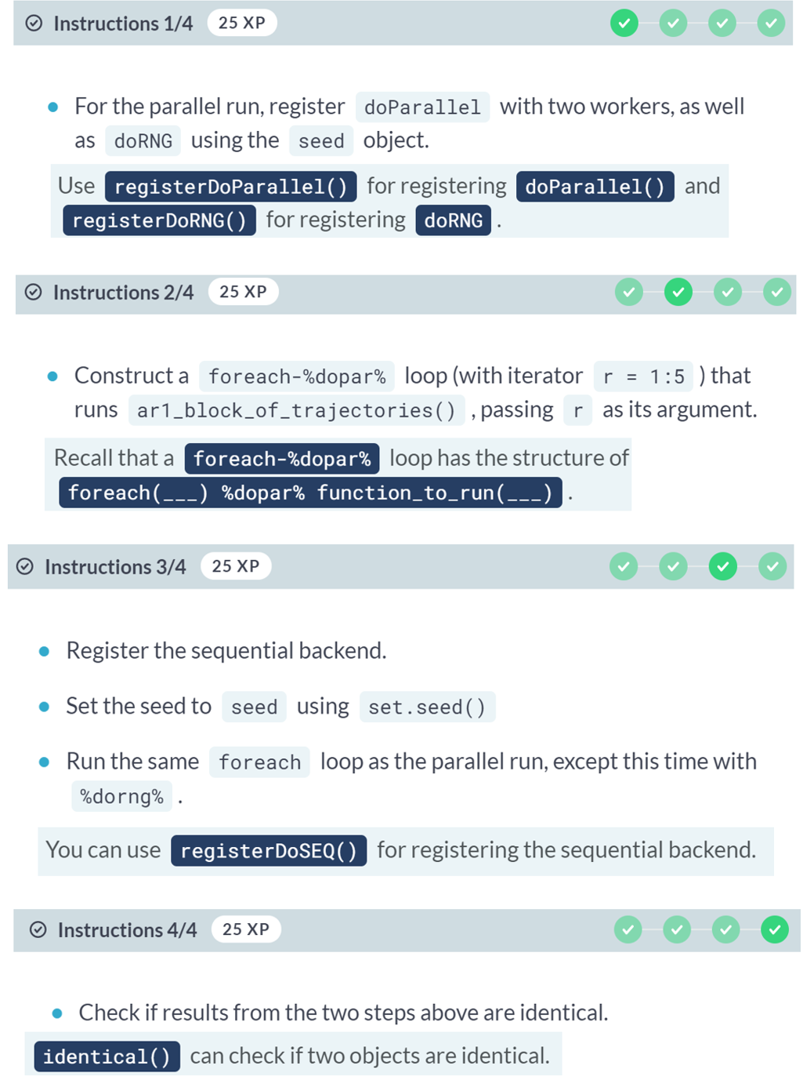

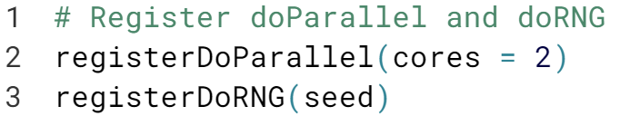





(Exercise continues on the next page)



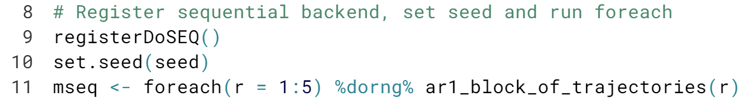



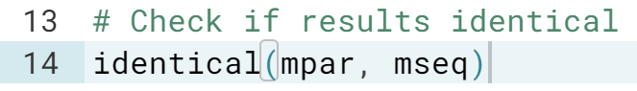  
  
(Summary available on the next page)

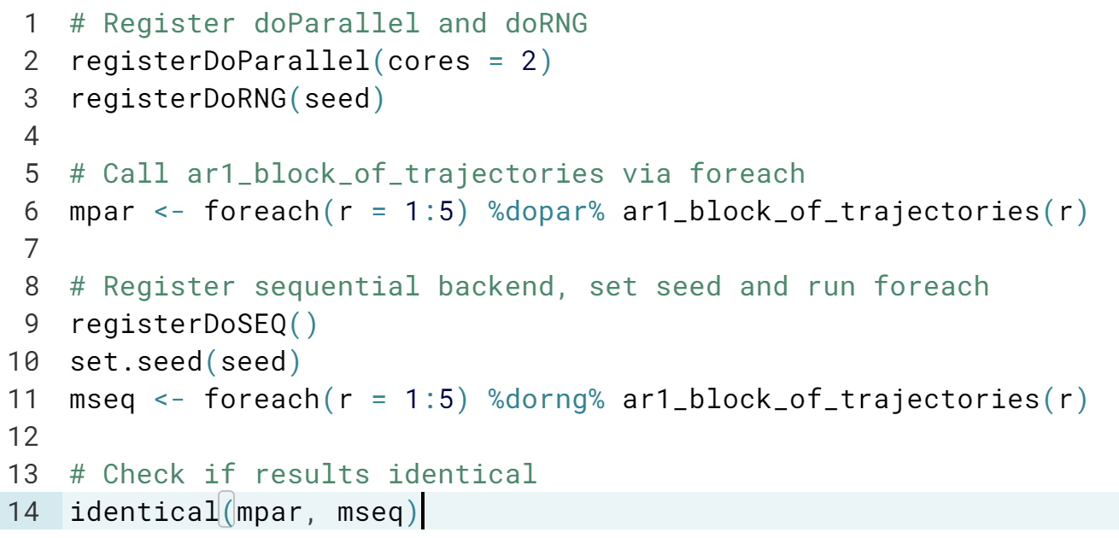

Fantastic! You are able to reproduce sequential and parallel applications!

Remember to always use ***%dorng%*** if you use the ***doSEQ backend.***

Also note that by default on the Linux DataCamp server, ***registerDoParallel()*** creates a FORK cluster if a number of cores is passed to it.

As a result, there was no need to export any functions to workers, as they were copied from the master. On a different platform, the ***.export*** option may be needed.

# Reproducing migration app with future.apply

In this exercise, you will implement the same application as before, but now using the future.apply package. The package is available in your workspace, as are all functions and datasets needed for this exercise. The seed is set to 999.

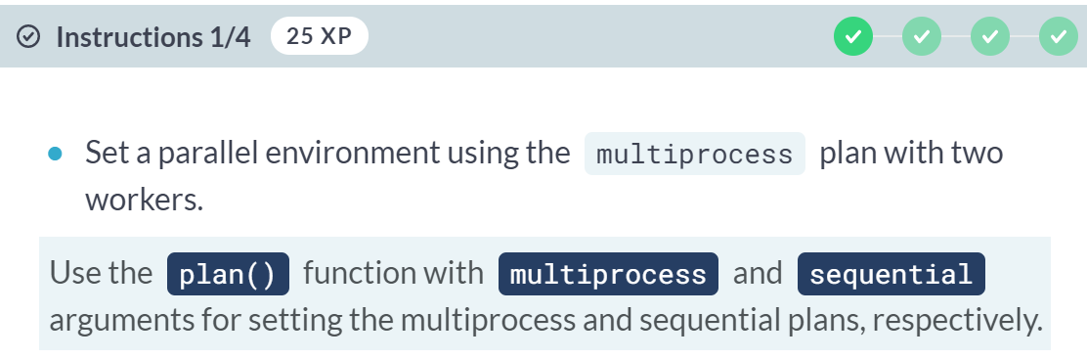

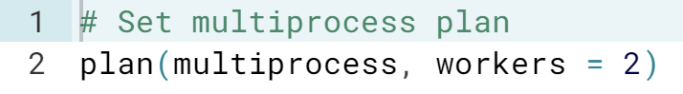

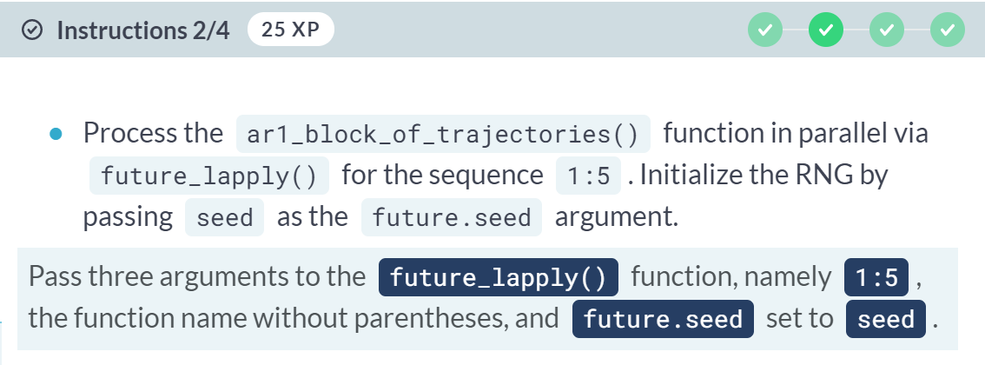



(Exercise continues on the next page)

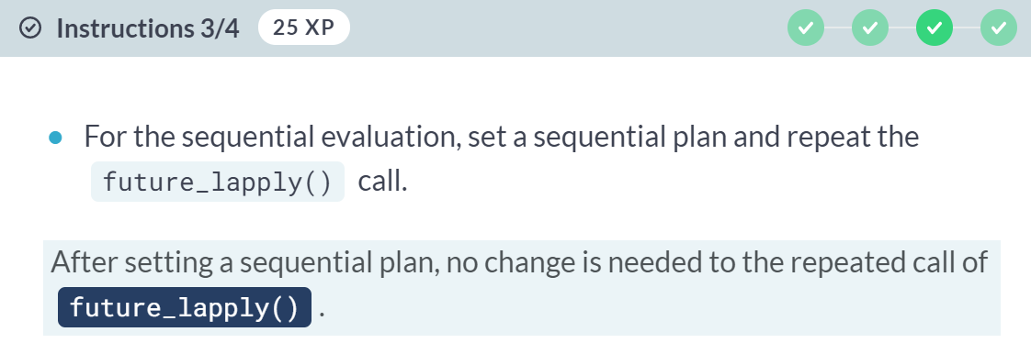



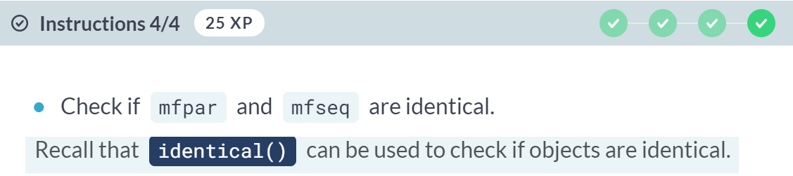

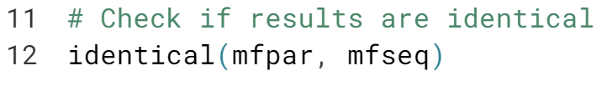

Magnificent! Setting ***future.seed*** in ***future_lapply()*** makes application always reproducible.

